How to Create a Save-List and Use for activating or inactivating a group of accounts (and performing inactivation using GLAT)
- Go to SLED
- Enter a new savedlist name (if creating a new savedlist)
- Enter an existing savedlist name (if editing an existing saved list)
- 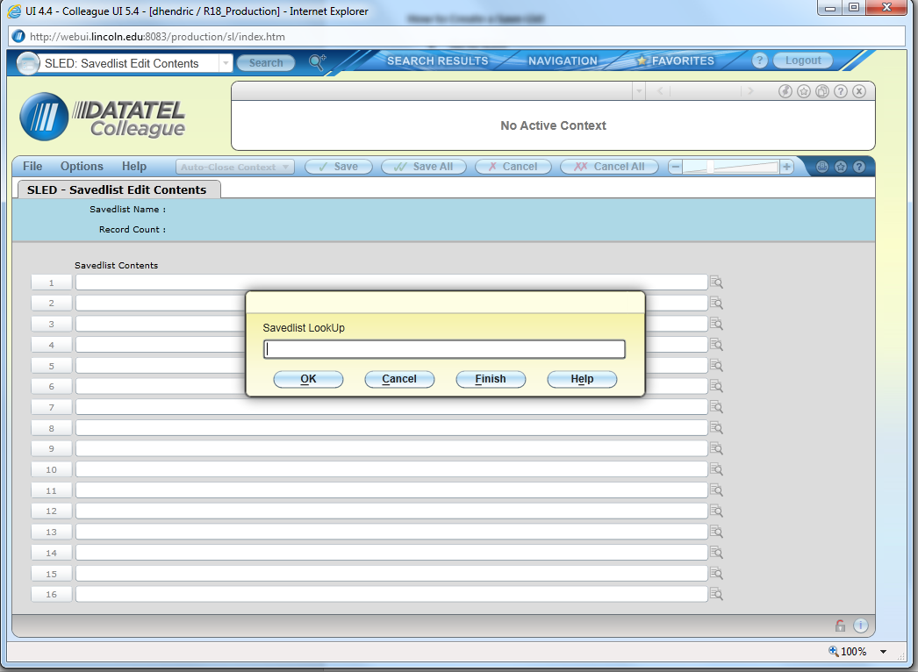

Enter new saved list name
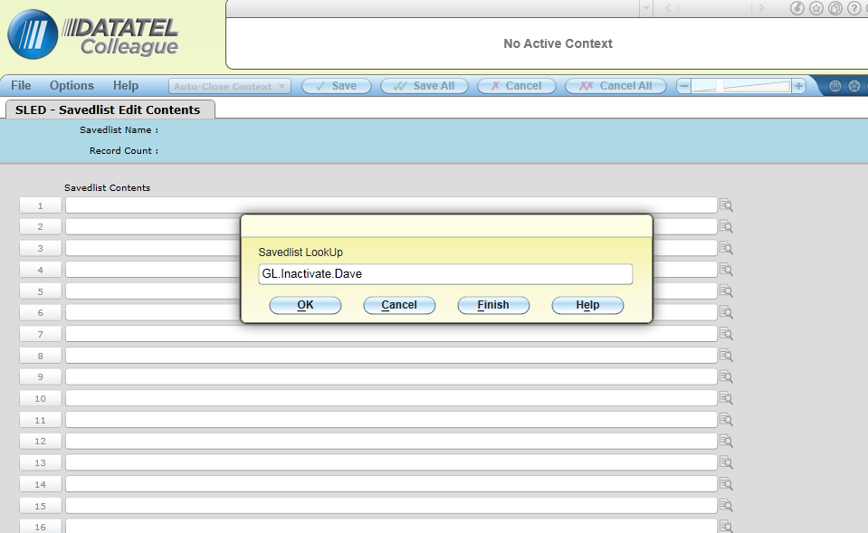
Select Add
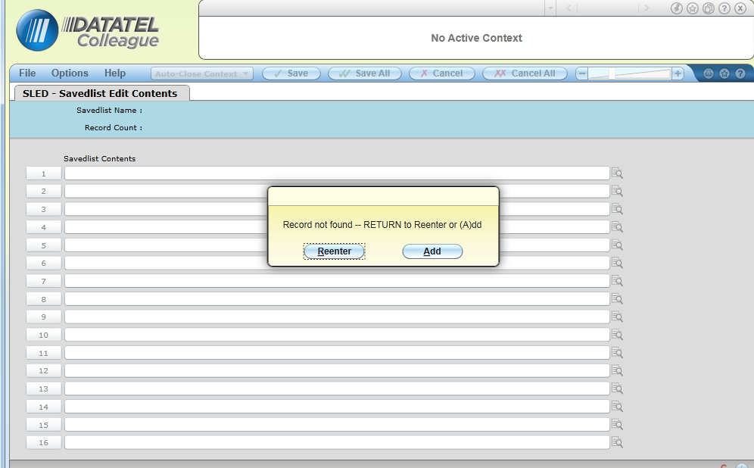
Below is what comes up when you add a new savedlist
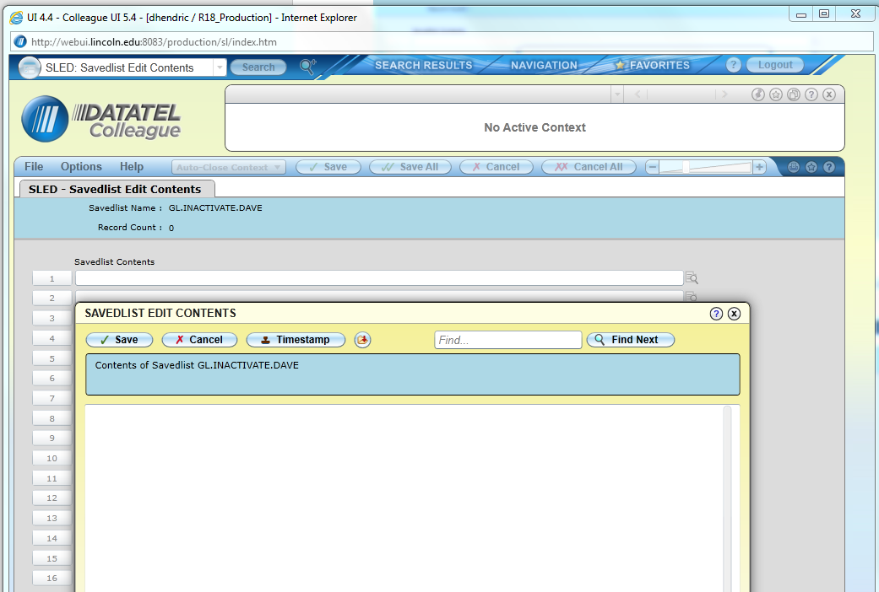

Select the GL accounts you wish to add by cutting and pasting out of an excel spreadsheet. Make sure there is no blank row at the bottom of the data. The curser should be at the end(right side) of the last account on the list.
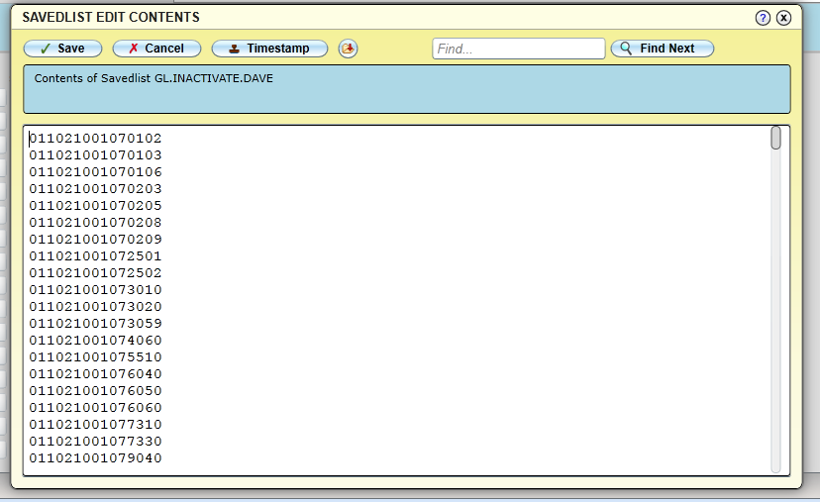

Select “Save” and you will see this screen. Then select save all. Your save list is now created.
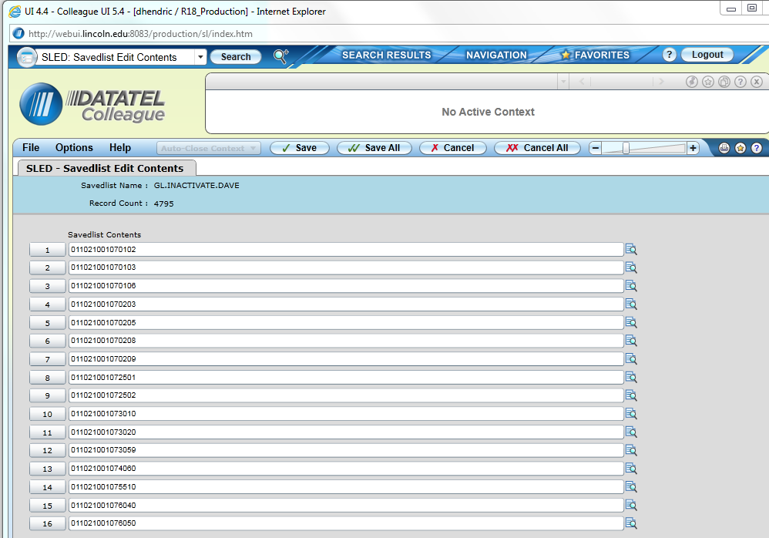

Below I’m using the newly created savedlist to run a GLTB to verify no balances before I use GLAT to inactivate accounts. Enter “L” for list name in the “Select/List” box.
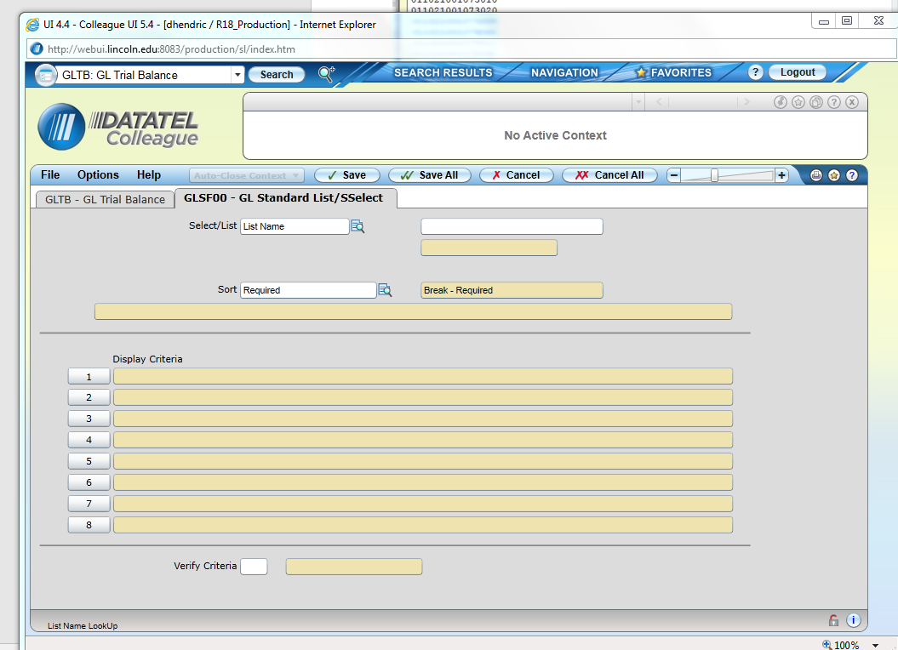

Once you enter “L” in the “Select List” box, Enter your savedlist name in the box to the right. (Note the display criteria shows the first 8 items on the list.
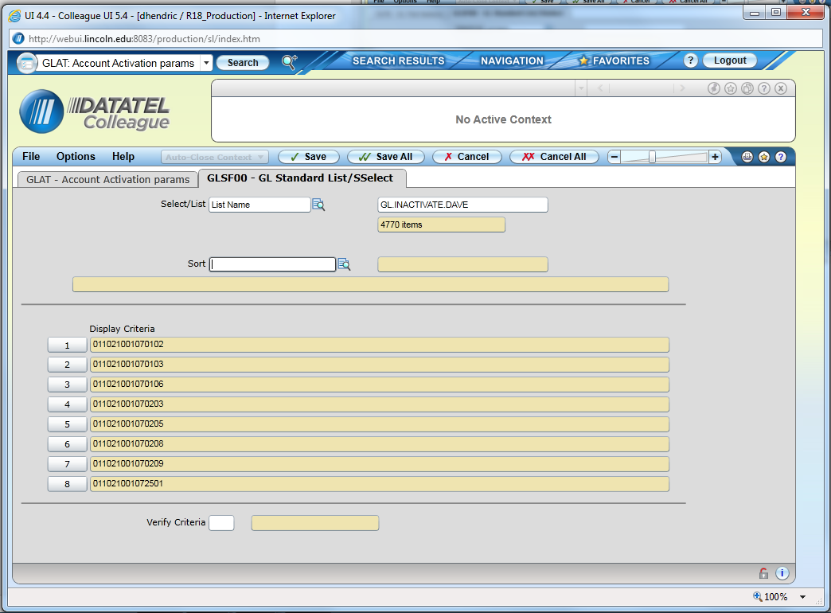

Having reviewed the results of my GLTB, I am now ready to inactivate the accounts using GLAT. The selection screen that comes up for “GL Account Definition) is the same as for GLTB. Follow the same steps from above and select save to return to the below screen. In the example below I entered “Yes” to “Proceed with Activation”, which inactivated all accounts on the list.

