YEAR END CLOSING PROCEDURE
Summary Steps in Grid Below
Step | Complete? | Description | Note
FRX report |  | SofA | Make sure match audit report - May need to match to GLTB since update of data no longer running
FRX report |  | Balance Sheet | Make sure match audit report - May need to match to GLTB since update of data no longer running
GLME |  | Close all Fiscal periods up to and including month 11
GLTB |  | Summary for year to close. | Make sure balanced
YFBV |  | For year to close | Make sure no encumbrance errors to correct - Send to Jen
GLVA |  | Summary to Actual for year to close
GLVA |  | Actual to summary for year to close
GLVA |  | Glaccts to summary for year to close
GLVA |  | Summary to Glaccts for year to close
GLVA |  | Encumbrance for year to close | Will need to correct encumbrance errors found in YFBV
SLCR |  | GL_INACTIVE - save with year to close - Ask Jen
SLCR |  | GL_FROZE - save with year to close - Ask Jen
GLAT |  | Activate for GL_INACTIVE savelist
GPES |  | Make sure no errors for year to close
MACS |  | Open all accts for year to close
MACS |  | Open all accts for current year
GLYE |  | Complete preverification checklist
GLYE |  | Complete preprocessing steps - Encumbrance/Fund Balance Verification
GLYE |  | Complete preprocessing steps - Closing Automatic Entries
GLYE |  | Complete preprocessing steps - Closing Balance verification
GLYE |  | Complete preprocessing steps - Summary General Ledger Trial Balance (Req)
No more entry of transactions to post to GL
PGLT |  | post all transactions
Make sure backup complete
Quiet System
GLYE |  | Complete final processing steps - Close General Ledger Accounts
GLYE |  | Complete final processing steps - Create Opening Balances
PGLT |  | Post Transactions
GLAT |  | Inactivate for GL_INACTIVE savelist
GLTB |  | Summary for closed year
GLTB |  | Summary for current year

Detail of Steps Below
Run FRX Reports used to generate financial statements
Balance Sheet
- Run FRX Balance Sheet for year being closed (Currently LLH_BS-DH-MD2014)
- Run GLTB for All Assets at the end of the year being closed
- Run GLTB for All Liabilities at the end of the year being closed
- Verify that total assets and total liabilities tie between FRX and the GL
- Verify that the FRX report ties to the audit for the year being closed

Income Statement
- Run FRX Income Statement for year being closed (Currently S-of-A DH-2014)
- Run GLTB for All Revenues at the end of the year being closed
- Run GLTB for All Expenses at the end of the year being closed
- Verify that total revenue and total expense tie between FRX and the GL
- Verify that the FRX report ties to the audit for the year being closed

Run YFBV (Fund Balance Verification) – Accept Default Sort Order

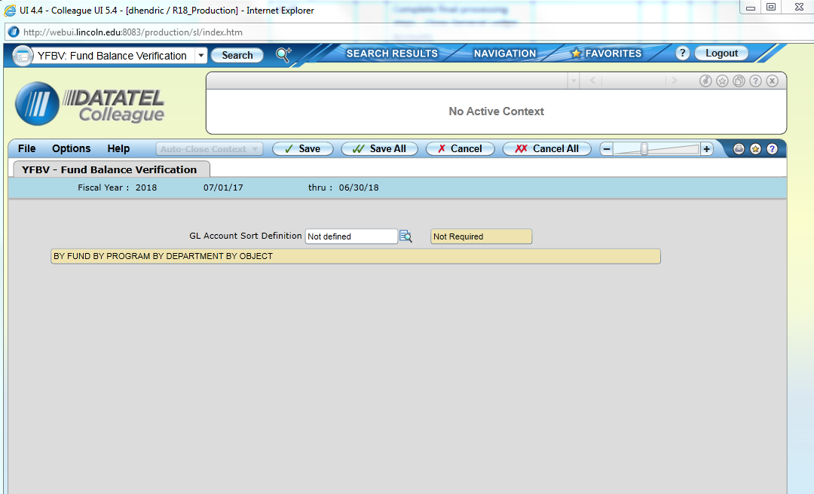
This is the screen you will see after YFBV runs

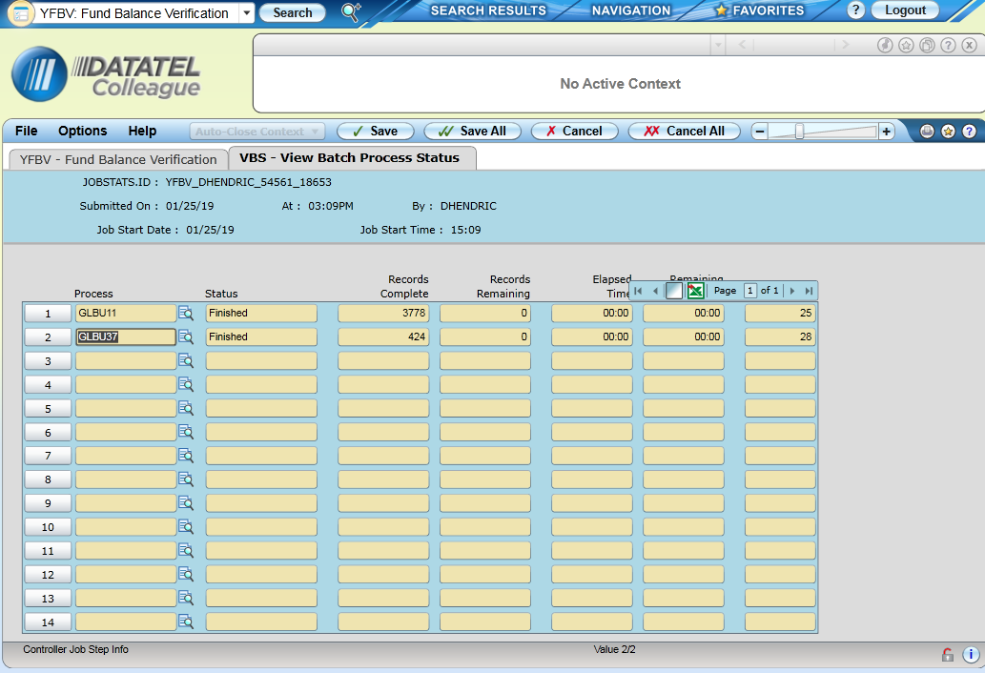

Click on magnifying glass and export errors to Excel. (For GLBU11 and GLBU37)

Review and Fix Errors (Likely need the help of the Business Systems Analyst)

Run GLVA for the 5 “Yes” items below (Everything but “verify transaction balance” – Don’t ever run this)
Select “Save All” and Allow to process (This should take a little over an hour)
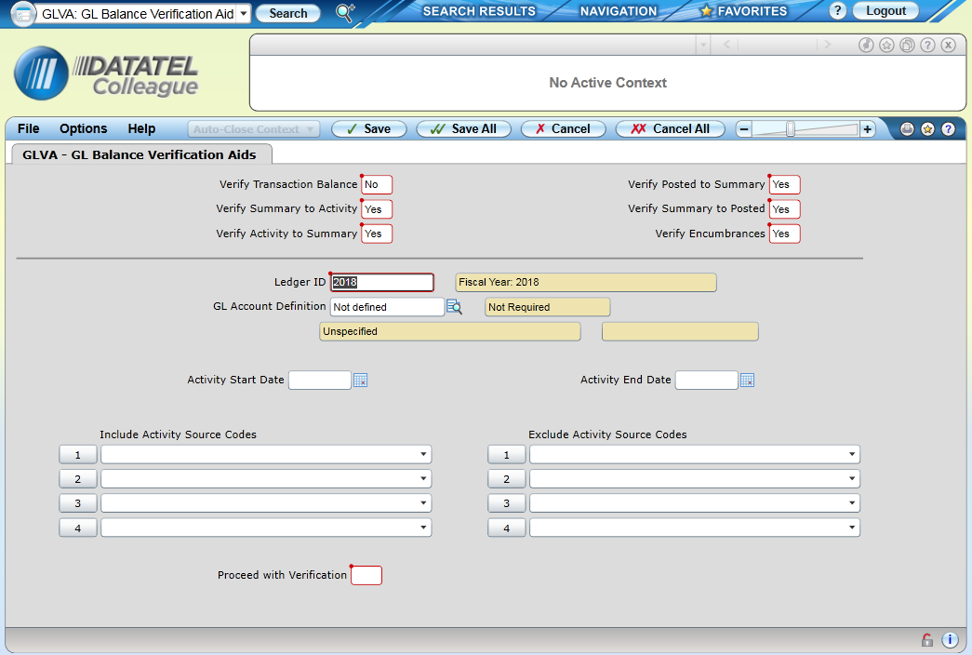

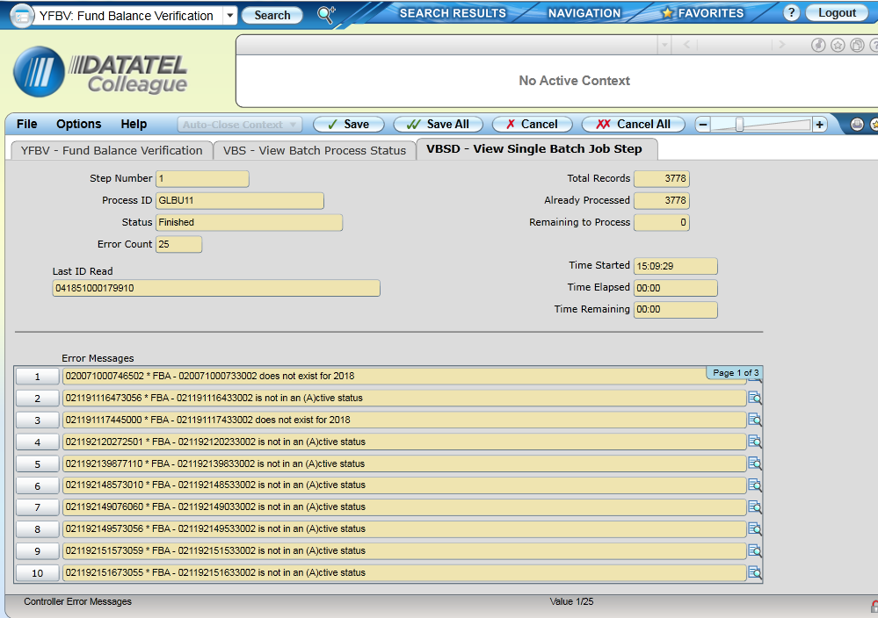

SLCR - GL Inactive – Save with Year to Close

Run SLCR – creates a saved list of records matching criteria in query to be used in subsequent functions
- SavedList Specification Lookup = GL_INACTIVE
- Select OK
- Modify the Savedlist Name to Save Results under = GL_INACTIVE_YYyy where YYyy is the year you are closing
- Note: Be careful when modifying savedlists. Selecting on the row will highlight the entire row. You need to click again where you want to make the change, otherwise typing will replace entire row.
- Record Not Found – RETURN to Reenter or (A)dd = A
- Save All

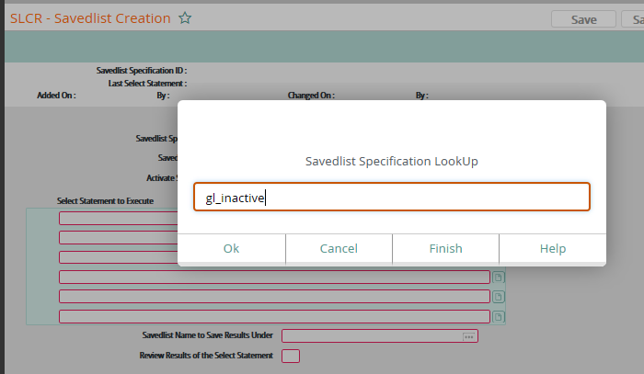

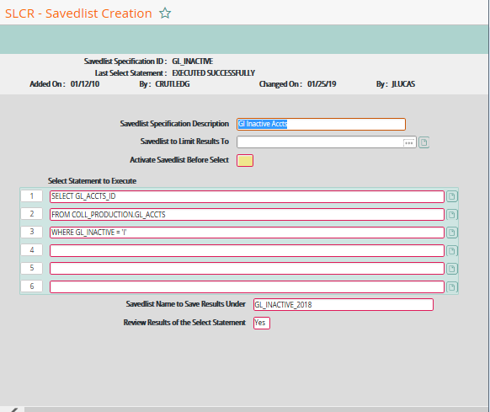
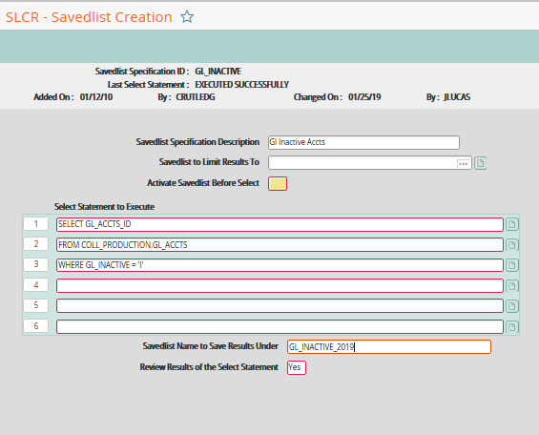

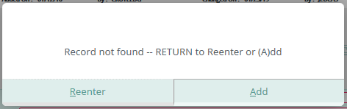

SLCR - GL Froze – Save with Year to Close
Run SLCR – creates a saved list of records matching criteria in query to be used in subsequent functions
- SavedList Specification Lookup = GL_FROZE
- Select OK
- Modify the year in the Select statement Available_funds_controller=”YYyy” where YYyy is the year you are closing
- Modify the Savedlist Name to Save Results under = GL_FROZE_yy where yy is the year you are closing
- Note: Be careful when modifying savedlists. Selecting on the row will highlight the entire row. You need to click again where you want to make the change, otherwise typing will replace entire row.
- Record Not Found – RETURN to Reenter or (A)dd = A
- Save All
- Don’t worry if you don’t get any records. There have been no accounts frozen for many years.

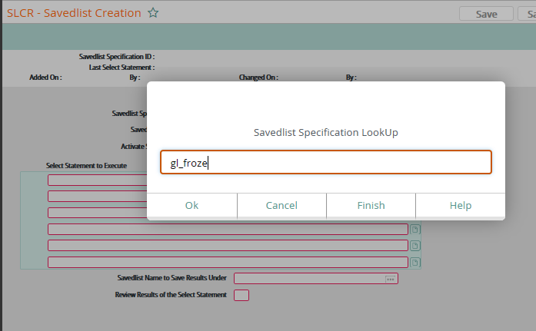

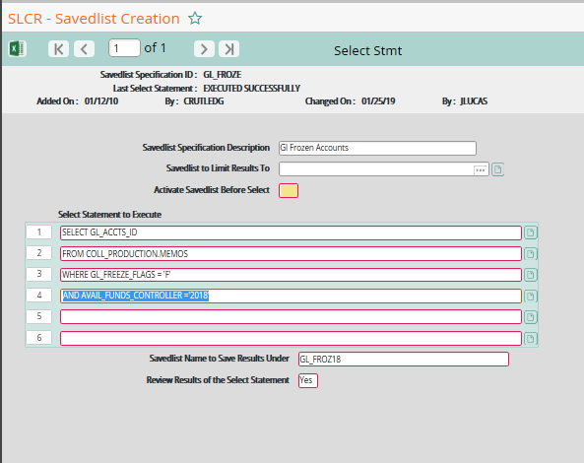
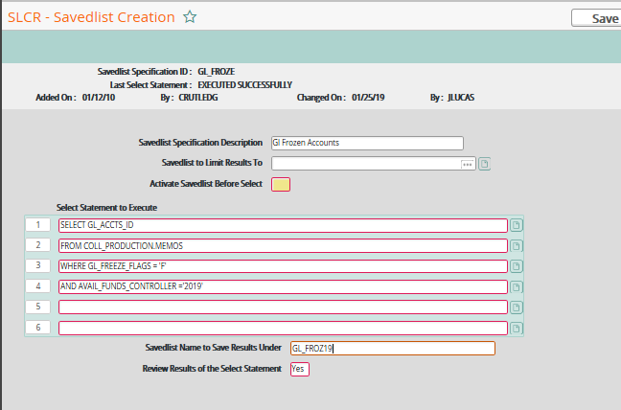

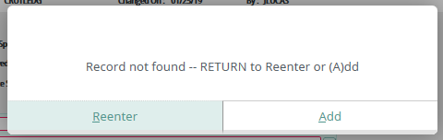

GLAT – Run this to activate inactive accounts on the save list
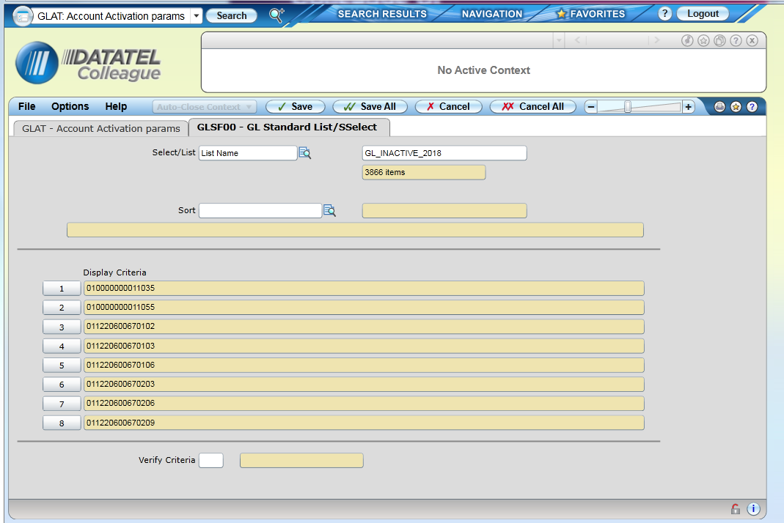

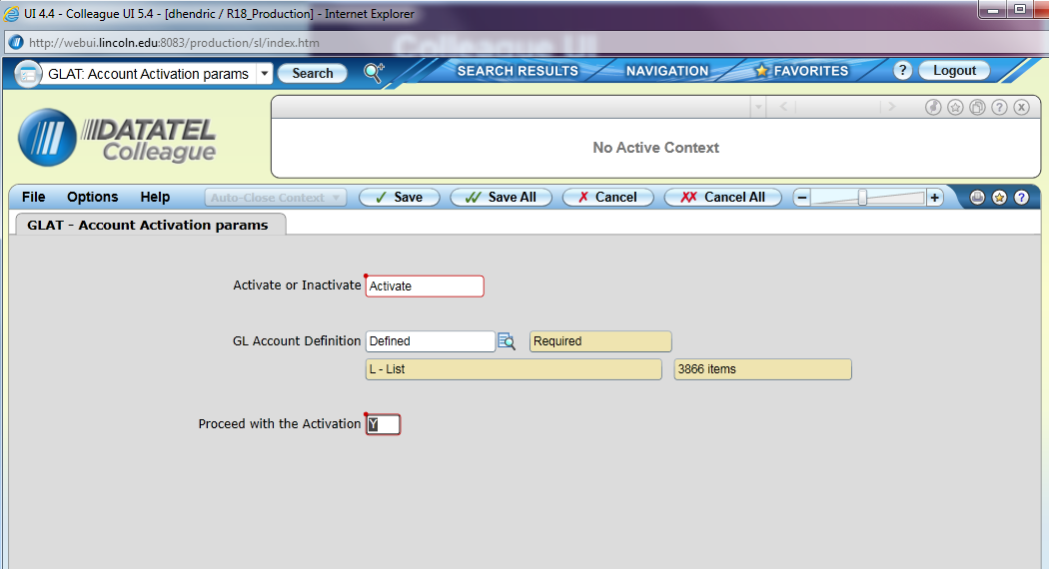

Save a copy of the activated accounts as pdf and CSV in case needed
Run “GPES” – If no errors show, move on to the next step. If errors, work with system administrator to fix before proceeding.

Run “MACS” – Open all accounts for the year to close.
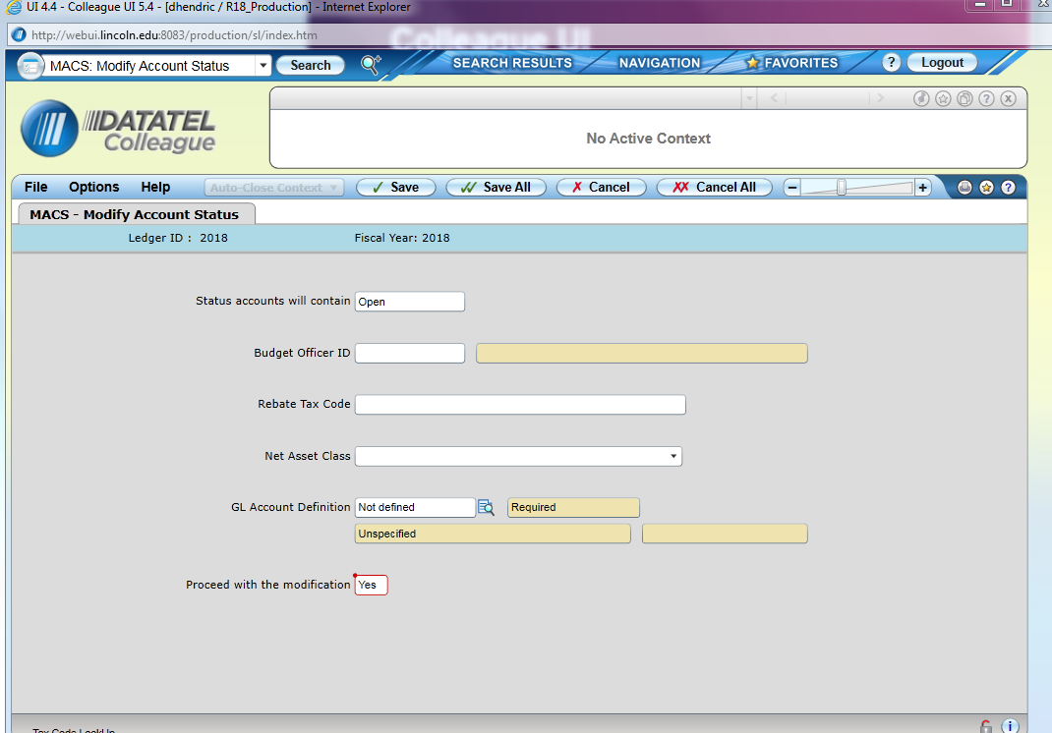
Use “SA” to “select all” for GL Account definition
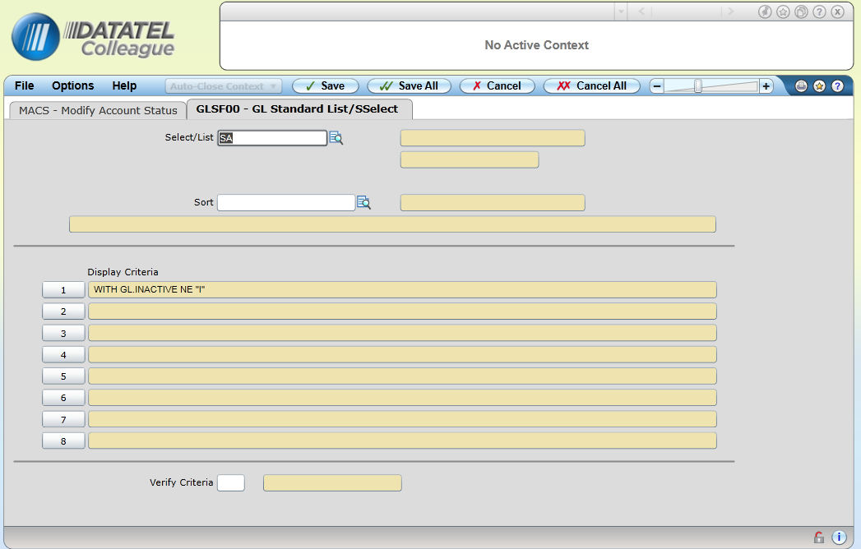

Run “MACS” – Open all accounts for the current year.

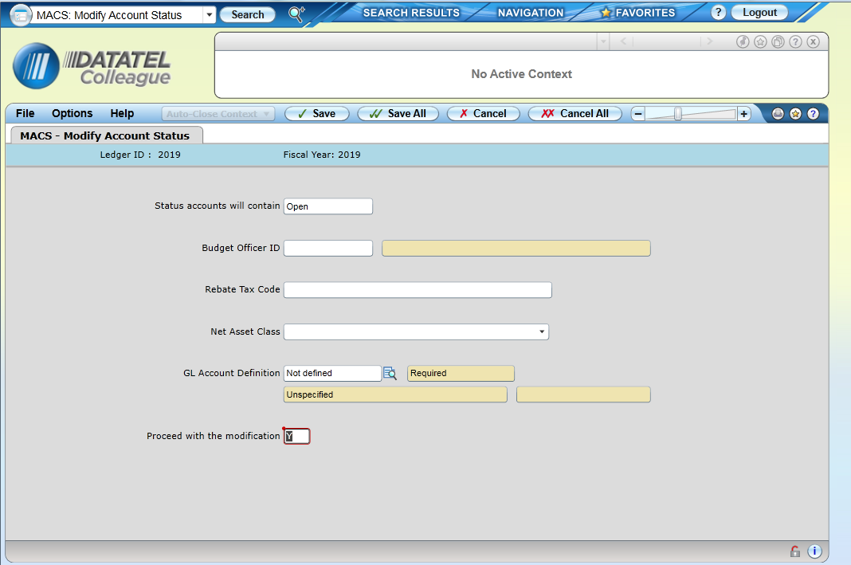
Use “SA” to “select all” for GL Account definition
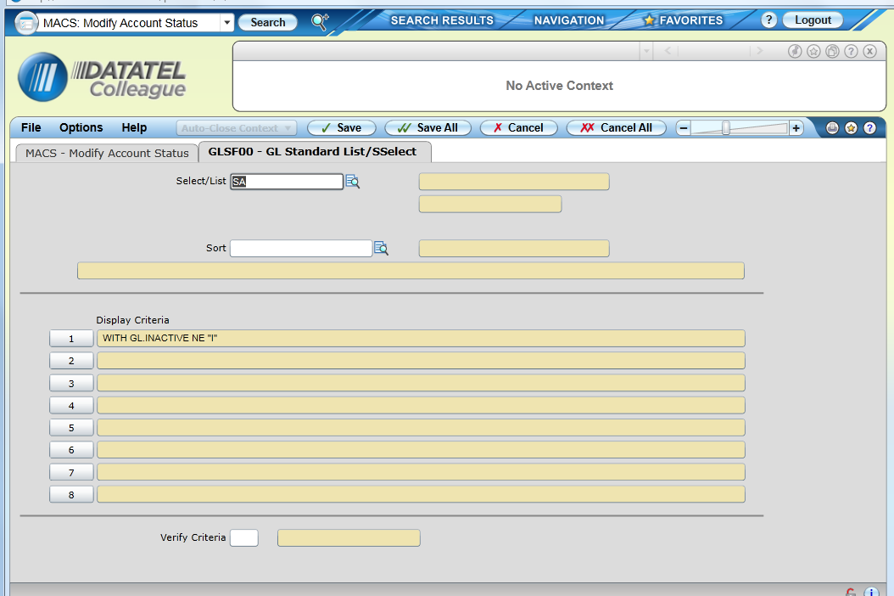

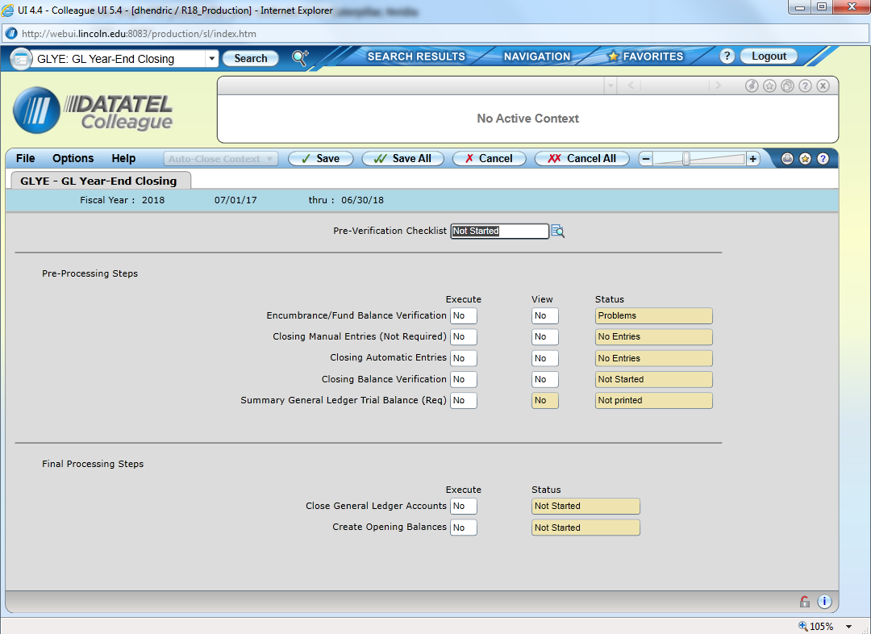

Complete Pre-Verification Checklist
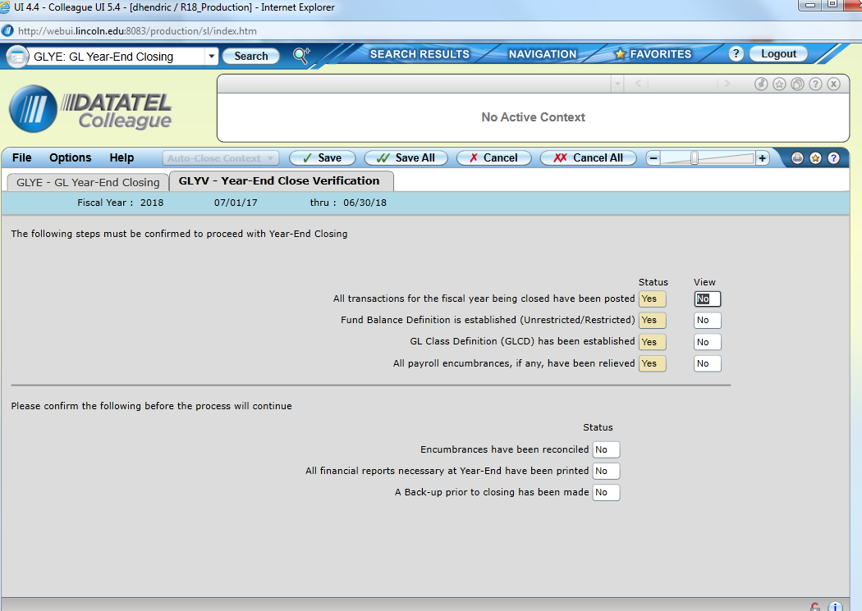

View “all transactions for the fiscal year being closed have been posted” – Should have “yes” status and the view should give you a null report

“Fund Balance Definition is established” (Should have “yes” status) – This won’t change unless we do a major system overhaul

“GL Class Definition” – (Should have “yes” status) This won’t change unless we do a major system overhaul

“All Payroll Encumbrances, if any, have been relieved” - Should have “yes” status and the view should give you a null report

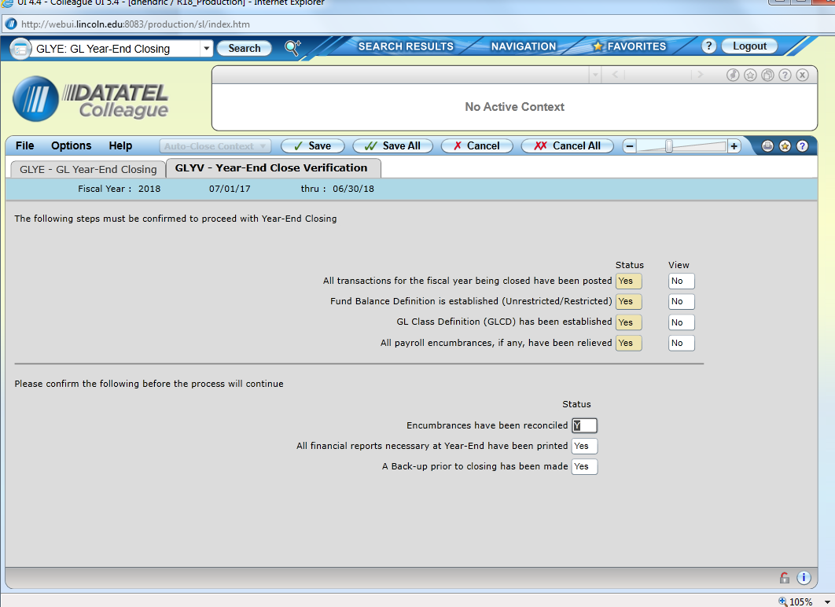

Confirm the above 3 status before beginning pre-processing steps – Then Select “Save All”

Go back into “GLYE” and your pre-verification checklist should read complete
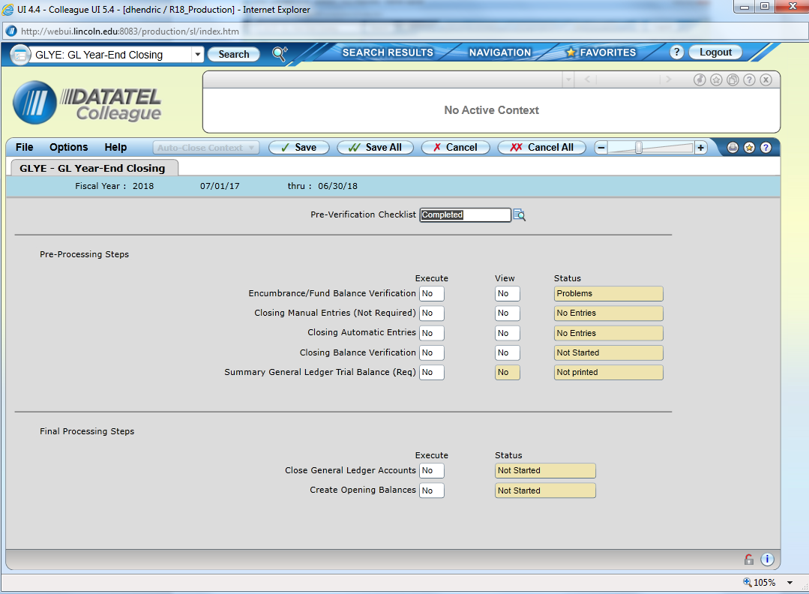

Execute the Pre-Processing Steps one by one

Encumbrance/Fund Balance Verification – Note, due to the way we use the encumbrance system, this will show “problems.” As long as all issues related to encumbrance are resolved that show up in “YFBV” we are OK.

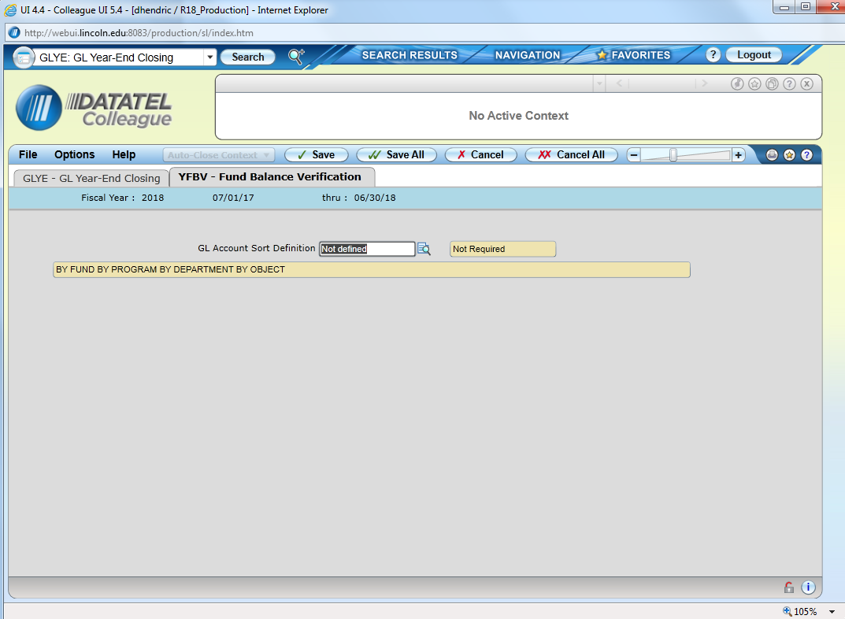
Above is Encumbrance/Fund Balance Verification screen (What is seen after you answer “yes” to execute.)

Select “Save All”
Select “Finish”
No Report will print
This will bring you back out of GLYE…(You will need to re-enter GLYE)

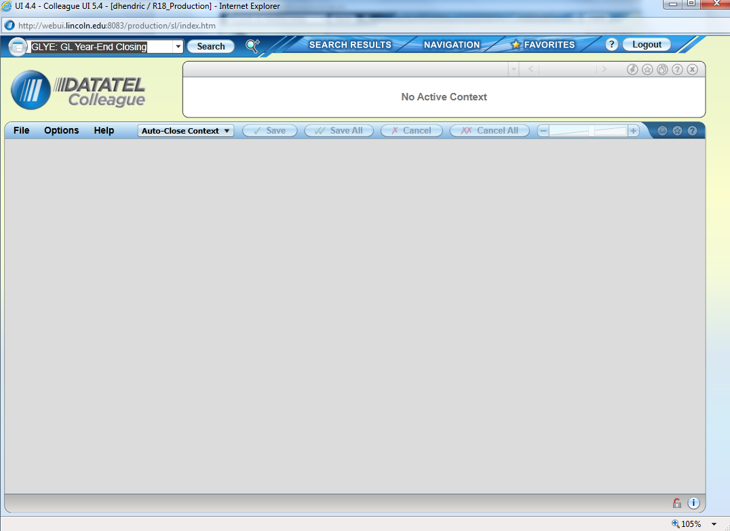

Once you re-enter GLYE you will see the first step is complete (see below)
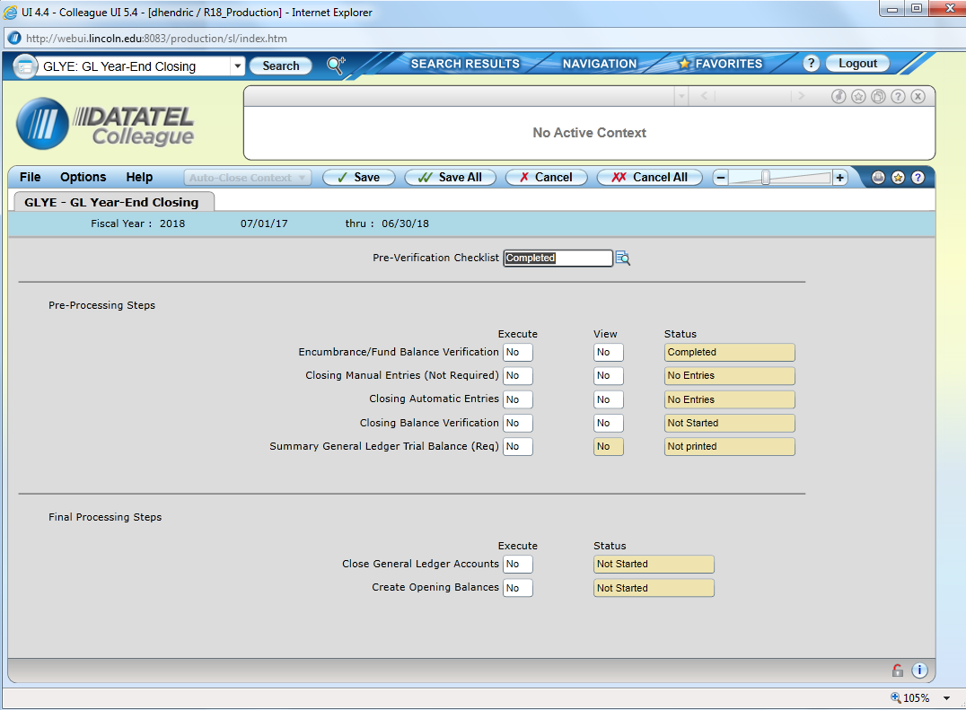
Skip the process “Closing Manual Entries (Not Required)”
Execute “closing automatic entries” – Say yes to “Create” “Report” and “Post”

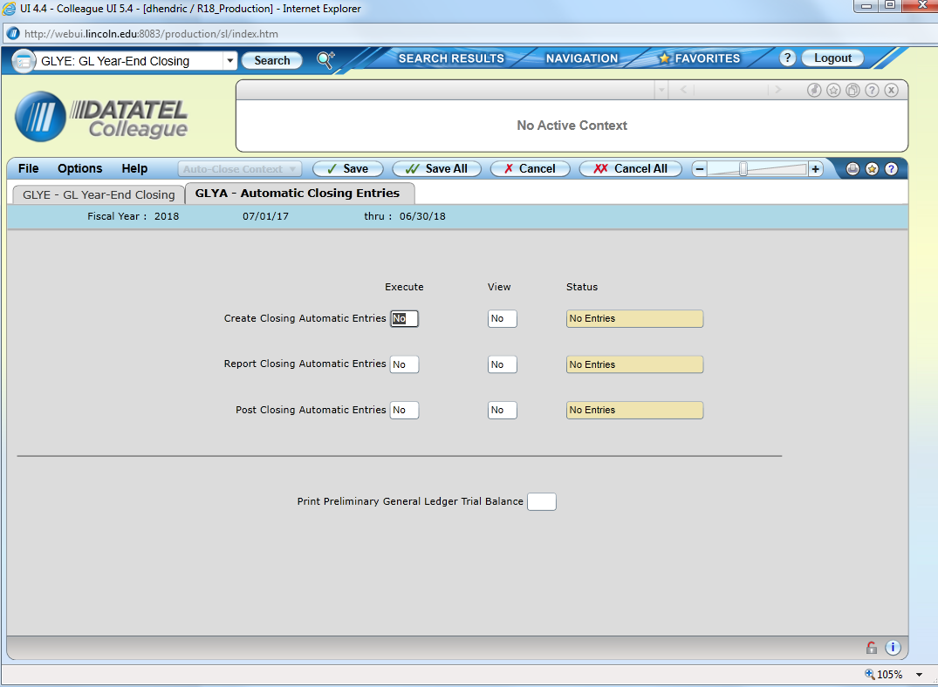

This Screen will come up for “Create” – Select “Save All”

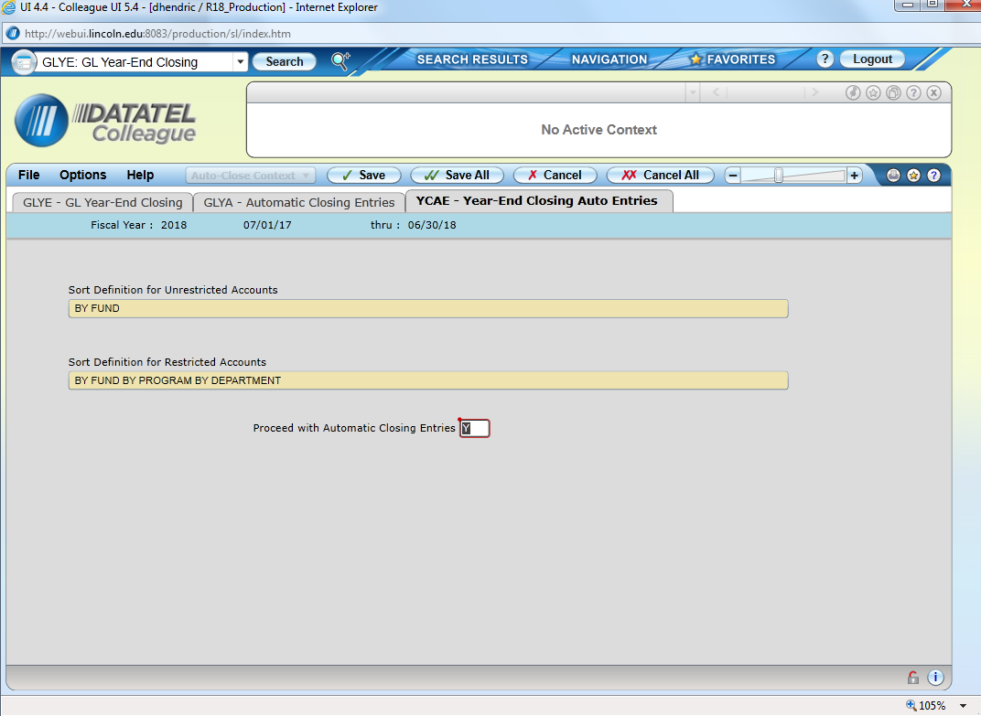

The below screen will come up for “Report” – Select “Save All”
Will create two reports: Detail and Summary
When the reports complete Save as PDF and CSV.
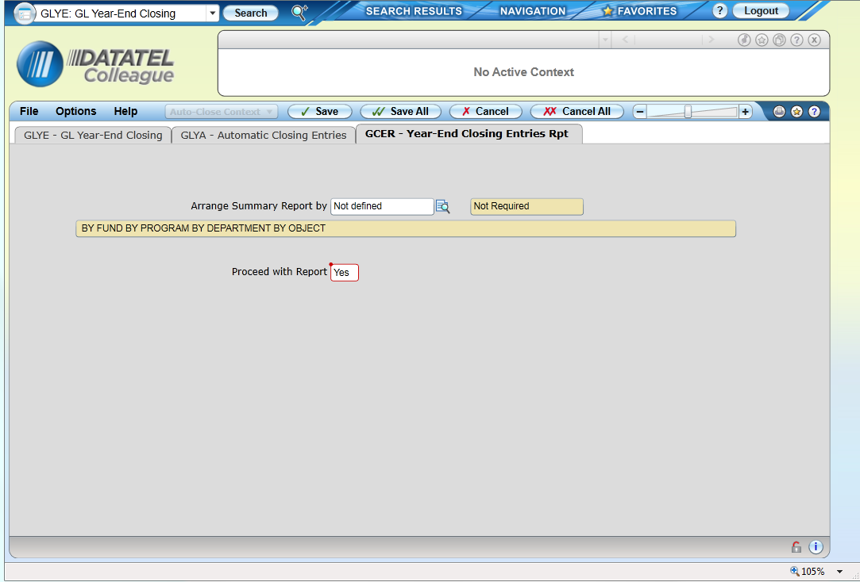

Execute “Post Closing Automatic Entries”
Save Posted Entry report as PDF and CSV

Execute “Closing Balance Verification”
A Screen will appear as seen below – Select “Save All”
No report will print

Execute “Summary General Ledger Trial Balance”
A screen like the below will appear – Select “Save All.”

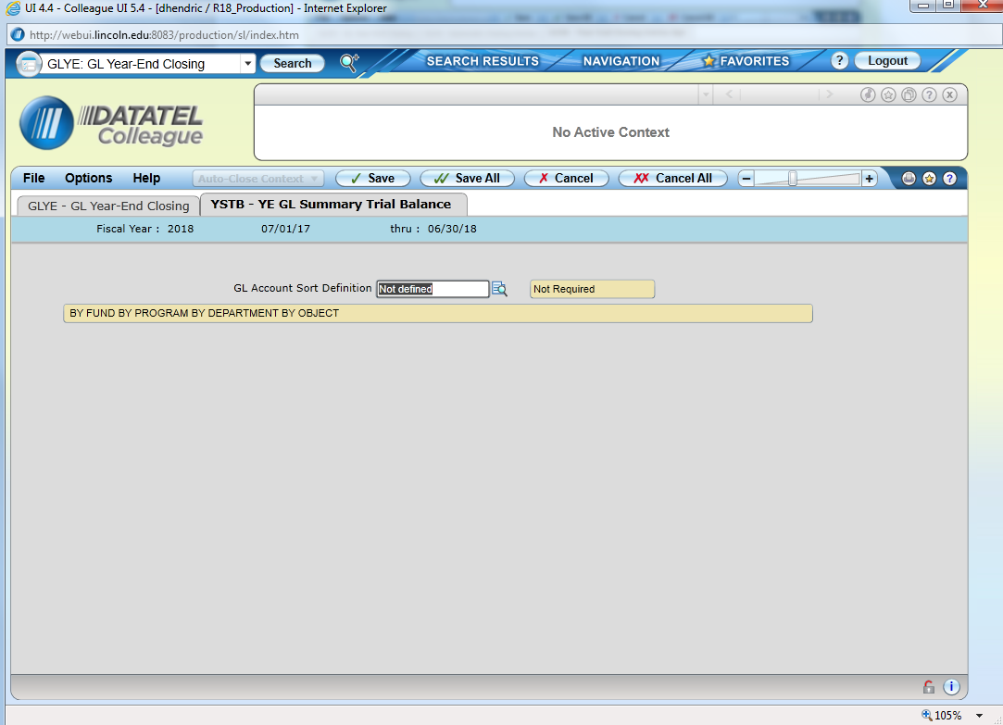

Print Final GLTB and Save as PDF and CSV

After all Pre-Processing steps are done, your screen will look like this (below)
Before Proceeding to the Final Processing Steps – Contact Information Technology and Let them know that we are about to close the prior fiscal year. FRX report writer will need to be updated to know that the year will be close.
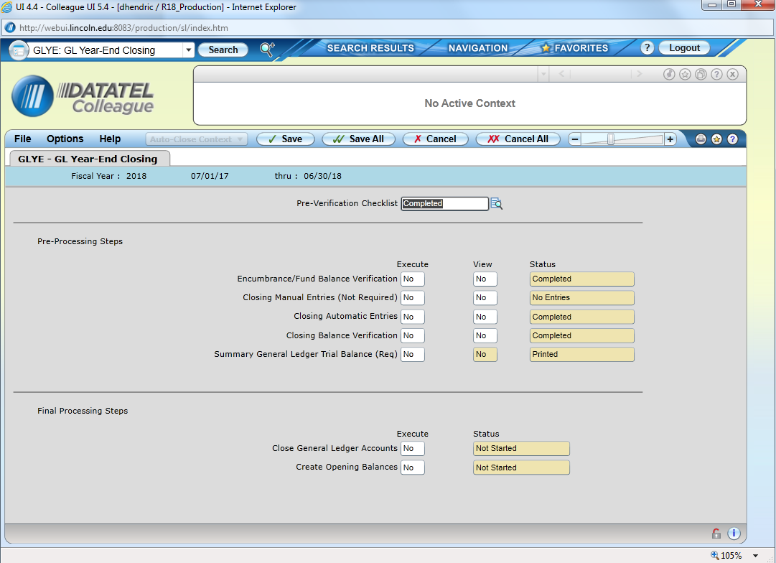

Final Processing Steps – GL part of the system needs to be quite. Bursar, Purchasing, and Accounts Payable off of Colleague)

Run “Close General Ledger Accounts”
Run “Create Opening Balances”
Run GLAT – Select Save-list GL_Incactive – for the year being closed
Run a summary GLTB for the year being closed – Verify in balance and save
Run a summary GLTB for the current year (use current year end date to make sure everything is captured) – Verify in balance and Save

