To verify full upload prior to running reports.
Type “FRXL”

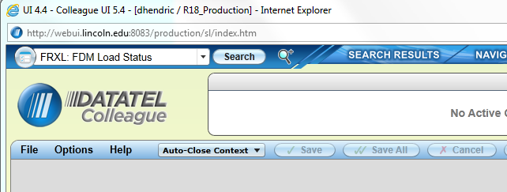

Enter three dots “…” then “OK”

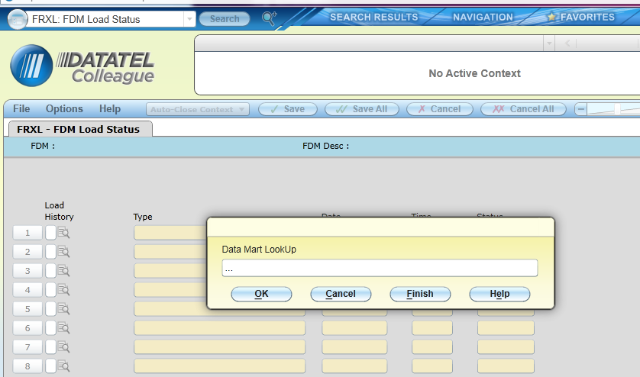

Verify “Success” for the morning that you were running the report.

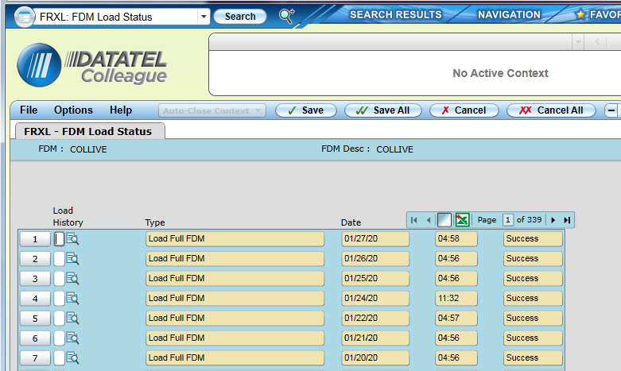

To Run Incremental Upload (for changes made during the day.)
First run “PGLT”
Then Run “FRXI”

Enter three dots “…” then “OK”

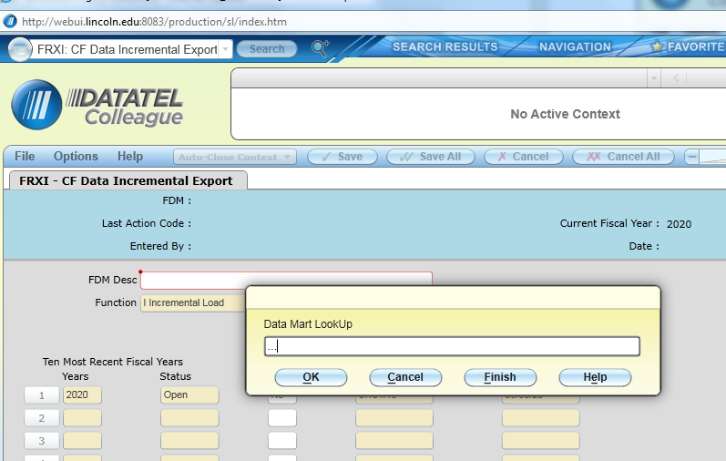
Put “Y” in the box next to the Fiscal Year you wish to update and select save all. The update process will take about 10 minutes to run.

Monthly Conformance Reporting
- Use the month end closing checklist in Business Office\Journal Entry “JE Close Checklist” to verify that all closing entries have been made
- Before Running any FRX Reports, Make sure PGLT is posted. Then Run FRXI to update the FRX database
- Produce first review copy of the month by running the following reports in FRX
  - SOA Report
  - Conformance Report
SOA Report
- Log in to FRX
- Select SOA 101018

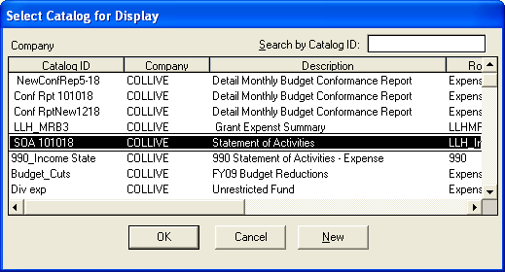
- Verify report date is the one you want (FRX defaults to the last month that ended)
- Select “Generate Report”
- Below is the generated report
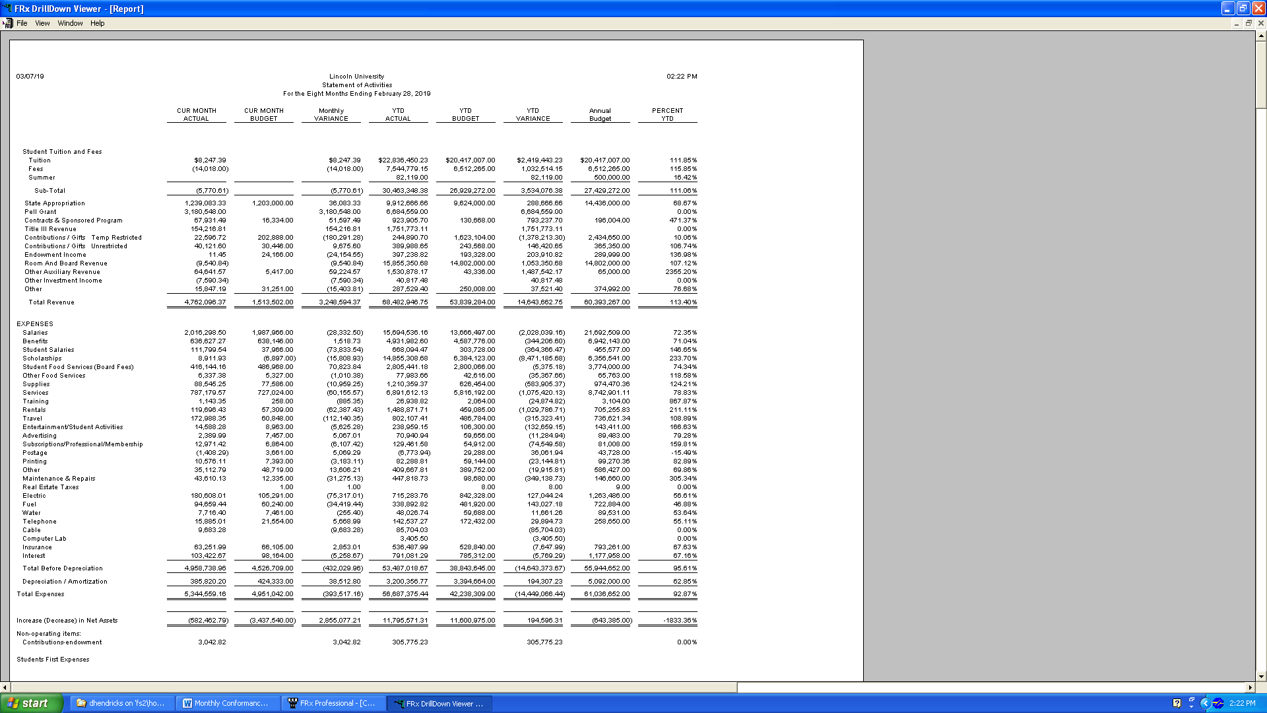

- Select “File” “Print” – Make sure print layout is Landscape for both page setup and printer setup
- Now that you have printed the file. Save a Copy to excel as follows
  - Selecte “File” “Export” “Worksheet File” “Excel Via Ole”
  - Select Financial Report – Detail Supporting Report – Account Details
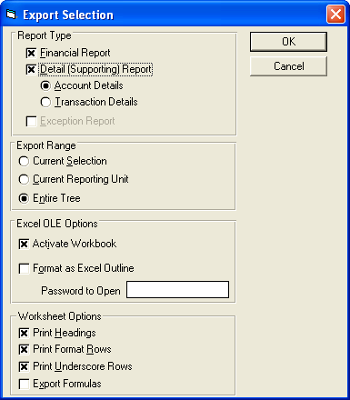
- Save the file for future use – Save final for each month on the Business Office Drive “Conformance Reports”

Conformance Report
- Select ConfRptNew0419
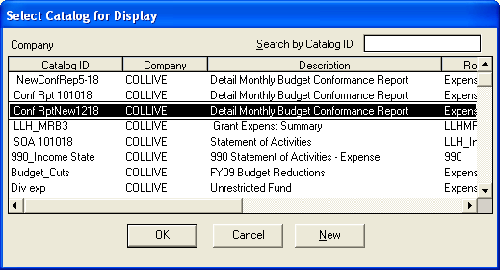
- Select Generate Report (Make sure you have the correct month)
- Select “Mark All” and “OK”
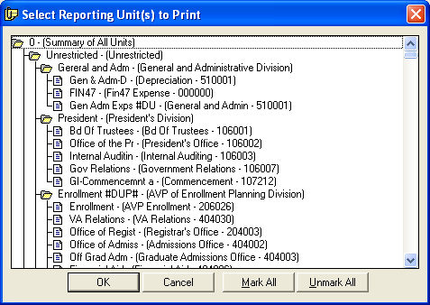
- This report will take 1.5 to 2 hours to generate. A window will show progress. (See Below)
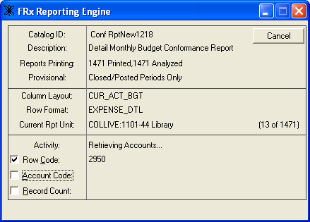

- When the report completes a screen will appear like this

- Select “File” “Print” “Entire Tree” – Make sure print layout is Landscape for both page setup and printer setup
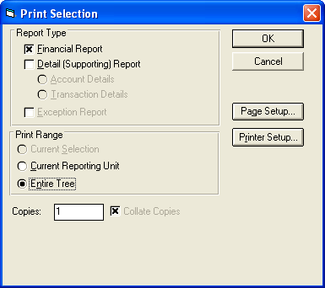

- Now that you have printed the file. Save a Copy to excel as follows
  - Select “File” “Export” “Worksheet File” “Excel Via Ole”
  - Export “Entire Tree”
  - Name the Report “Conformance Report – MM-YY”
  - Save this report WITHOUT any detail (Supporting) Report

- Now complete the same exact steps you performed to generate the conformance report for the report “ConfRptDetail04019” DO NOT PRINT – VERY LARGE
  - Select “File” “Export” “Worksheet File” “Excel Via Ole”
  - Export “Entire Tree”
  - Name the Report “Detail Conformance Report – MM-YY”
  - Save this report WITH detail (Supporting) Report (Select Transaction Details)

Now that you have generated and saved the Summary and Detail Conformance Reports, save a copy of each to the business office drive conformance reports folder under “conformance reports distributed”
P:\Conformance Reports\Conformance Reports – Distributed (A file is set up for each month)

The Financial Assistant, Office of the Controller (Dawn Reif at the time of this writing) will separate the Summary and Detail Reports and distribute via e-mail according to the distribution list that is copied from the prior month’s file. There is also verbiage for the transmittal to the departments in the prior months file that Dawn updates and pastes into the e-mail transmitting the reports.

Updated 1/9/2020

