ARPN – AC/CR Posting Analysis Report

Use the AR/CR Posting Analysis report to compare transactions posted to Accounts Receivable with what has been posted to the General Ledger. When you run this report, you can select one of the following levels of detail:
- SD - Summary by Date. Summarizes the transactions by source and by date.
- GL - Summary by GL Ref Nos. Summarizes the transactions by source, by date, and by GL reference number.
- DT - Detail Level. Lists each AR transaction by source and by date, including each individual AR transaction posted for that GL reference number.
You can also generate a spreadsheet that contains the report data.
The SD –Summary by Date report is run each week to ensure all AR subsidiary records have posted to the GL for AR types 01, 02 and 03 and all Trans types. It can be generated for any date range within a fiscal year. See screenshot below.
Occasionally you may need to know what transactions have not posted or you may have an invoice number and need to know what the transaction is or for which student. The DT – Detail Level report can be used to extract this data.
AR Types 01, 02 and 03 are the types that will post to 01_00_000000_11410 – Accts Rec –Student
Other Ar Types that exist are:
- 05 - Col Ag Prog Student Receivabl
- 06 - Col Ag CMS Student Receivable
- 10 - Spons Bill Student Receivable
- 12 - Employee Receivables
- 15 - Previously Written Off AR
- COAT - COATESVILLE A/R
Trans Types are:
- IV Invoices
- CR Cash Receipts
- FA Financial Aid Transmittal
- DP Deposit Allocation
- PJ Purchase Journal
- PR Payroll

Weekly Summary Report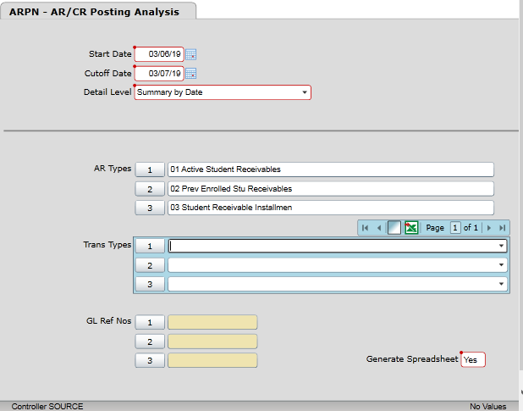
Save all
Change Output Device to H
Save all
Execute in background mode = N
Save all
Wait till you get the download message for your generated download or the actual report. Do not select Finish. This process will run several queries and display several progress bars. When all are finished it will finish and reports will be generated.

Spreadsheet sample
3/7/2019 |  | AR Posting Analysis
18:33 |  | Summary by Transaction Date
 |  | From 03/06/19 To 03/07/19
GL Acct Selected | AR Types Selected | Date | Src | AR Subsidiary | Posted to GL | Difference
01_00_000000_11410 | 01 02 03 | 3/6/2019 | IV | 10,856.00 | 10,856.00 | 0
01_00_000000_11410 | 01 02 03 | 3/7/2019 | IV | 2,836.62 | 0 | 2,836.62
01_00_000000_11410 | 01 02 03 | 3/6/2019 | CR | -32,723.98 | -15,062.80 | -17,661.18
01_00_000000_11410 | 01 02 03 | 3/7/2019 | CR | -12,482.04 | 0 | -12,482.04
01_00_000000_11410 | 01 02 03 | 3/6/2019 | FA | -166,263.00 | -144,178.00 | -22,085.00
01_00_000000_11410 | 01 02 03 | 3/6/2019 | PJ | 1,556.60 | 1,556.60 | 0
01_00_000000_11410 | 01 02 03 | 3/7/2019 | PJ | 98,509.31 | 98,509.31 | 0

Detail report for same criteria as Summary Report
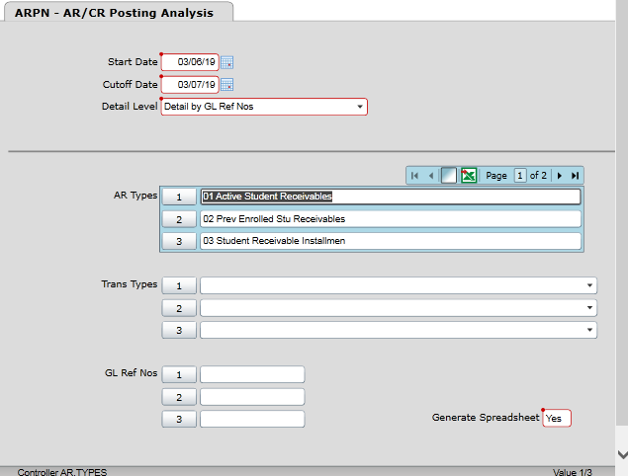
Save all
Change Output Device to H
Save all
Execute in background mode = N
Save all
Wait till you get the download message for your generated download or the actual report. Do not select Finish. This process will run several queries and display several progress bars. When all are finished it will finish and reports will be generated.

Spreadsheet example below
- If CGLP, IGLP, FGLP OR DGLP has been run you will see a GL Ref No
- If PGLT has been run you will see a GL Ref No and no difference
- If GL Ref No is UNPOSTED – One of the xGLP processes and PGLT need to run
- The Acct ID is the student ID

GL Acct Selected | AR Types Selected | Date | Src | GL Ref No | Trans ID | Acct ID | AR Type | Term | Trans No | Trans Description | AR Subsidiary | Posted to GL | Difference
01_00_000000_11410 | 01 02 03 | 3/7/2019 | IV | I000498595 | 714033 | 0176900 | 01 | 2019SP | 000498595 | Registration - 2019SP | -5,414.00
01_00_000000_11410 | 01 02 03 | 3/7/2019 | IV | I000498595 |  |  |  |  |  |  |  | -5,414.00 | 0
01_00_000000_11410 | 01 02 03 | 3/7/2019 | IV | I000498596 | 714032 | 0176900 | 01 | 2019SP | 000498596 | Registration - 2019SP | 5,414.00
01_00_000000_11410 | 01 02 03 | 3/7/2019 | IV | I000498596 |  |  |  |  |  |  |  | 5,414.00 | 0
01_00_000000_11410 | 01 02 03 | 3/7/2019 | IV | UNPOSTED | 714262 | 0128271 | 01 | 2019SP | 000498694 | ASLR 409D | -3,315.00
01_00_000000_11410 | 01 02 03 | 3/7/2019 | IV | UNPOSTED | 714261 | 0128271 | 01 | 2019SP | 000498695 | ASLR 409D | 3,374.00
01_00_000000_11410 | 01 02 03 | 3/7/2019 | IV | UNPOSTED | 714168 | 0167388 | 01 | 2019SP | 000498625 | Registration - 2019SP | -5,235.00
01_00_000000_11410 | 01 02 03 | 3/7/2019 | CR | C000093795 | 396743 | 0233625 | 01 | 2019SP | 000093795 | Payment, Thank You | -10
01_00_000000_11410 | 01 02 03 | 3/7/2019 | CR | C000093795 |  |  |  |  |  |  |  | 0 | -10
01_00_000000_11410 | 01 02 03 | 3/7/2019 | CR | C000093797 | 396747 | 0232464 | 01 | 2019SU | 000093797 | Payment, Thank You | -1,000.00
01_00_000000_11410 | 01 02 03 | 3/7/2019 | CR | C000093797 |  |  |  |  |  |  |  | 0 | -1,000.00
01_00_000000_11410 | 01 02 03 | 3/7/2019 | CR | C000093813 | 396749 | 0146704 | 01 | 2018FA | 000093813 | Payment, Thank You | -5,000.00
01_00_000000_11410 | 01 02 03 | 3/7/2019 | CR | C000093813 |  |  |  |  |  |  |  | 0 | -5,000.00
01_00_000000_11410 | 01 02 03 | 3/7/2019 | CR | C000093815 | 396759 | 0139301 | 01 | 2013FA | 000093815 | Payment, Thank You | -100
01_00_000000_11410 | 01 02 03 | 3/7/2019 | CR | C000093815 |  |  |  |  |  |  |  | 0 | -100
01_00_000000_11410 | 01 02 03 | 3/7/2019 | CR | UNPOSTED | 396707 | 0223116 | 01 | 2019SP | 000093782 | Web Payment-Thank You | -303
01_00_000000_11410 | 01 02 03 | 3/7/2019 | CR | UNPOSTED | 396705 | 0233807 | 01 | 2019SP | 000093780 | Web Payment-Thank You | -300
01_00_000000_11410 | 01 02 03 | 3/7/2019 | CR | UNPOSTED |  |  |  |  |  |  |  | 0 | -603

Detail Report for only the dates with unposted CR transactions on the Summary report
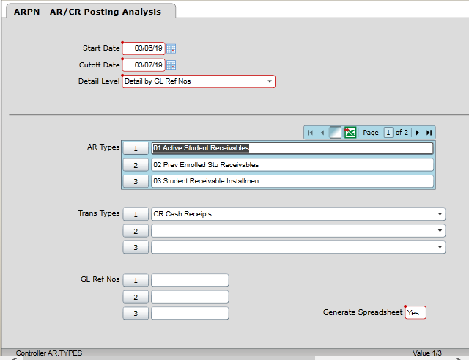

Save all
Change Output Device to H
Save all
Execute in background mode = N
Save all
Wait till you get the download message for your generated download or the actual report. Do not select Finish. This process will run several queries and display several progress bars. When all are finished it will finish and reports will be generated.

Spreadsheet example below
- In this example CGLP has been run for 3/6/2019 but PGLT has not
- CGLP for 3/7/2019 cannot be run until 3/8/2019. The session is open till midnight 3/7/19 and the cashier will reconcile 3/8/2019 morning.
GL Acct Selected | AR Types Selected | Date | Src | GL Ref No | Trans ID | Acct ID | AR Type | Term | Trans No | Trans Description | AR Subsidiary | Posted to GL | Difference
01_00_000000_11410 | 01 02 03 | 3/6/2019 | CR | C000093705 | 396329 | 0223244 | 01 | 2019SP | 000093705 | Web Payment-Thank You | -3,100.00
01_00_000000_11410 | 01 02 03 | 3/6/2019 | CR | C000093705 |  |  |  |  |  |  |  | 0 | -3,100.00
01_00_000000_11410 | 01 02 03 | 3/6/2019 | CR | C000093706 | 396330 | 0058670 | 01 | 2018SU | 000093706 | Web Payment-Thank You | -300
01_00_000000_11410 | 01 02 03 | 3/6/2019 | CR | C000093706 |  |  |  |  |  |  |  | 0 | -300
01_00_000000_11410 | 01 02 03 | 3/6/2019 | CR | C000093707 | 396331 | 0198611 | 01 | 2018FA | 000093707 | Web Payment-Thank You | -400
01_00_000000_11410 | 01 02 03 | 3/6/2019 | CR | C000093707 | 396332 | 0198611 | 01 | 2019SP | 000093707 | Web Payment-Thank You | -219
01_00_000000_11410 | 01 02 03 | 3/6/2019 | CR | C000093707 |  |  |  |  |  |  |  | 0 | -619
01_00_000000_11410 | 01 02 03 | 3/6/2019 | CR | C000093708 | 396333 | 0223802 | 01 | 2019SP | 000093708 | Payment, Thank You | -500
01_00_000000_11410 | 01 02 03 | 3/6/2019 | CR | C000093708 |  |  |  |  |  |  |  | -500 | 0
01_00_000000_11410 | 01 02 03 | 3/6/2019 | CR | C000093709 | 396334 | 0226000 | 01 | 2019SP | 000093709 | Payment, Thank You | -500
01_00_000000_11410 | 01 02 03 | 3/6/2019 | CR | C000093709 |  |  |  |  |  |  |  | -500 | 0
01_00_000000_11410 | 01 02 03 | 3/6/2019 | CR | C000093710 | 396336 | 0224956 | 01 | 2019SP | 000093710 | Web Payment-Thank You | -181.76
01_00_000000_11410 | 01 02 03 | 3/6/2019 | CR | C000093710 |  |  |  |  |  |  |  | 0 | -181.76
01_00_000000_11410 | 01 02 03 | 3/6/2019 | CR | C000093711 | 396335 | 0223722 | 01 | 2019SP | 000093711 | Payment, Thank You | -375
01_00_000000_11410 | 01 02 03 | 3/6/2019 | CR | C000093711 |  |  |  |  |  |  |  | -375 | 0
01_00_000000_11410 | 01 02 03 | 3/6/2019 | CR | C000093712 | 396337 | 0228151 | 01 | 2019SP | 000093712 | Payment, Thank You | -750
01_00_000000_11410 | 01 02 03 | 3/6/2019 | CR | C000093712 |  |  |  |  |  |  |  | -750 | 0
01_00_000000_11410 | 01 02 03 | 3/6/2019 | CR | C000093714 | 396338 | 0233507 | 01 | 2019SP | 000093714 | Payment, Thank You | -500
01_00_000000_11410 | 01 02 03 | 3/6/2019 | CR | C000093714 |  |  |  |  |  |  |  | -500 | 0
01_00_000000_11410 | 01 02 03 | 3/6/2019 | CR | C000093715 | 396340 | 0225257 | 01 | 2019SP | 000093715 | Payment, Thank You | -499
01_00_000000_11410 | 01 02 03 | 3/6/2019 | CR | C000093715 |  |  |  |  |  |  |  | -499 | 0
01_00_000000_11410 | 01 02 03 | 3/6/2019 | CR | C000093716 | 396341 | 0221655 | 01 | 2017FA | 000093716 | Payment, Thank You | -50
01_00_000000_11410 | 01 02 03 | 3/6/2019 | CR | C000093716 |  |  |  |  |  |  |  | -50 | 0
01_00_000000_11410 | 01 02 03 | 3/6/2019 | CR | C000093719 | 396342 | 0109458 | 01 | 2017FA | 000093719 | Payment, Thank You | -500
01_00_000000_11410 | 01 02 03 | 3/6/2019 | CR | C000093719 |  |  |  |  |  |  |  | -500 | 0
01_00_000000_11410 | 01 02 03 | 3/6/2019 | CR | C000093729 | 396343 | 0210410 | 01 | 2018SU | 000093729 | Web Payment-Thank You | -1.52
01_00_000000_11410 | 01 02 03 | 3/6/2019 | CR | C000093729 |  |  |  |  |  |  |  | 0 | -1.52
01_00_000000_11410 | 01 02 03 | 3/6/2019 | CR | C000093731 | 396344 | 0229538 | 01 | 2019SP | 000093731 | Web Payment-Thank You | -4,000.00
01_00_000000_11410 | 01 02 03 | 3/6/2019 | CR | C000093731 |  |  |  |  |  |  |  | 0 | -4,000.00
01_00_000000_11410 | 01 02 03 | 3/6/2019 | CR | C000093733 | 396346 | 0206841 | 01 | 2017SP | 000093733 | Payment, Thank You | -100
01_00_000000_11410 | 01 02 03 | 3/6/2019 | CR | C000093733 |  |  |  |  |  |  |  | -100 | 0
01_00_000000_11410 | 01 02 03 | 3/6/2019 | CR | C000093737 | 396347 | 0167213 | 01 | 2017FA | 000093737 | Payment, Thank You | -195
01_00_000000_11410 | 01 02 03 | 3/6/2019 | CR | C000093737 |  |  |  |  |  |  |  | -195 | 0
01_00_000000_11410 | 01 02 03 | 3/6/2019 | CR | C000093740 | 396348 | 0216297 | 01 | 2019SP | 000093740 | Payment, Thank You | -500
01_00_000000_11410 | 01 02 03 | 3/6/2019 | CR | C000093740 |  |  |  |  |  |  |  | -500 | 0
01_00_000000_11410 | 01 02 03 | 3/6/2019 | CR | C000093741 | 396349 | 0216297 | 01 | 2019SP | 000093741 | Payment, Thank You | 500
01_00_000000_11410 | 01 02 03 | 3/6/2019 | CR | C000093741 |  |  |  |  |  |  |  | 500 | 0
01_00_000000_11410 | 01 02 03 | 3/6/2019 | CR | C000093743 | 396350 | 0233507 | 01 | 2019SP | 000093743 | Payment, Thank You | 500
01_00_000000_11410 | 01 02 03 | 3/6/2019 | CR | C000093743 |  |  |  |  |  |  |  | 500 | 0
01_00_000000_11410 | 01 02 03 | 3/6/2019 | CR | C000093745 | 396351 | 0228151 | 01 | 2019SP | 000093745 | Payment, Thank You | 750
01_00_000000_11410 | 01 02 03 | 3/6/2019 | CR | C000093745 |  |  |  |  |  |  |  | 750 | 0
01_00_000000_11410 | 01 02 03 | 3/6/2019 | CR | C000093747 | 396352 | 0223722 | 01 | 2019SP | 000093747 | Payment, Thank You | 375
01_00_000000_11410 | 01 02 03 | 3/6/2019 | CR | C000093747 |  |  |  |  |  |  |  | 375 | 0
01_00_000000_11410 | 01 02 03 | 3/6/2019 | CR | C000093749 | 396353 | 0226000 | 01 | 2019SP | 000093749 | Payment, Thank You | 500
01_00_000000_11410 | 01 02 03 | 3/6/2019 | CR | C000093749 |  |  |  |  |  |  |  | 500 | 0
01_00_000000_11410 | 01 02 03 | 3/6/2019 | CR | C000093751 | 396354 | 0223802 | 01 | 2019SP | 000093751 | Payment, Thank You | 500
01_00_000000_11410 | 01 02 03 | 3/6/2019 | CR | C000093751 |  |  |  |  |  |  |  | 500 | 0
01_00_000000_11410 | 01 02 03 | 3/6/2019 | CR | C000093754 | 396663 | 0201262 | 01 | 2019SP | 000093754 | Web Payment-Thank You | -20
01_00_000000_11410 | 01 02 03 | 3/6/2019 | CR | C000093754 |  |  |  |  |  |  |  | 0 | -20
01_00_000000_11410 | 01 02 03 | 3/6/2019 | CR | C000093755 | 396667 | 0205093 | 01 | 2018SP | 000093755 | Payment, Thank You | -508.45
01_00_000000_11410 | 01 02 03 | 3/6/2019 | CR | C000093755 | 396668 | 0205093 | 01 | 2018FA | 000093755 | Payment, Thank You | -346.55
01_00_000000_11410 | 01 02 03 | 3/6/2019 | CR | C000093755 |  |  |  |  |  |  |  | -855 | 0
01_00_000000_11410 | 01 02 03 | 3/6/2019 | CR | C000093756 | 396669 | 0216940 | 01 | 2018FA | 000093756 | Payment, Thank You | -570
01_00_000000_11410 | 01 02 03 | 3/6/2019 | CR | C000093756 |  |  |  |  |  |  |  | -570 | 0
01_00_000000_11410 | 01 02 03 | 3/6/2019 | CR | C000093757 | 396670 | 0221598 | 01 | 2018FA | 000093757 | Web Payment-Thank You | -100
01_00_000000_11410 | 01 02 03 | 3/6/2019 | CR | C000093757 | 396671 | 0221598 | 01 | 2019SP | 000093757 | Web Payment-Thank You | -100
01_00_000000_11410 | 01 02 03 | 3/6/2019 | CR | C000093757 |  |  |  |  |  |  |  | 0 | -200
01_00_000000_11410 | 01 02 03 | 3/6/2019 | CR | C000093758 | 396672 | 0222476 | 01 | 2019SP | 000093758 | Web Payment-Thank You | -1,200.00
01_00_000000_11410 | 01 02 03 | 3/6/2019 | CR | C000093758 |  |  |  |  |  |  |  | 0 | -1,200.00
01_00_000000_11410 | 01 02 03 | 3/6/2019 | CR | C000093759 | 396673 | 0138648 | 01 | 2017FA | 000093759 | Web Payment-Thank You | -1,909.00
01_00_000000_11410 | 01 02 03 | 3/6/2019 | CR | C000093759 | 396674 | 0138648 | 01 | 2018SP | 000093759 | Web Payment-Thank You | -500
01_00_000000_11410 | 01 02 03 | 3/6/2019 | CR | C000093759 |  |  |  |  |  |  |  | 0 | -2,409.00
01_00_000000_11410 | 01 02 03 | 3/6/2019 | CR | C000093761 | 396678 | 0171991 | 01 | 2016FA | 000093761 | Web Payment-Thank You | -1
01_00_000000_11410 | 01 02 03 | 3/6/2019 | CR | C000093761 | 396679 | 0171991 | 01 | 2018FA | 000093761 | Web Payment-Thank You | -200
01_00_000000_11410 | 01 02 03 | 3/6/2019 | CR | C000093761 |  |  |  |  |  |  |  | 0 | -201
01_00_000000_11410 | 01 02 03 | 3/6/2019 | CR | C000093762 | 396680 | 0215190 | 01 | 2018SP | 000093762 | Payment, Thank You | -175
01_00_000000_11410 | 01 02 03 | 3/6/2019 | CR | C000093762 |  |  |  |  |  |  |  | -175 | 0
01_00_000000_11410 | 01 02 03 | 3/6/2019 | CR | C000093763 | 396681 | 0215190 | 01 | 2018SP | 000093763 | Payment, Thank You | -125
01_00_000000_11410 | 01 02 03 | 3/6/2019 | CR | C000093763 |  |  |  |  |  |  |  | -125 | 0
01_00_000000_11410 | 01 02 03 | 3/6/2019 | CR | C000093764 | 396682 | 0215190 | 01 | 2018SP | 000093764 | Payment, Thank You | -144.8
01_00_000000_11410 | 01 02 03 | 3/6/2019 | CR | C000093764 |  |  |  |  |  |  |  | -144.8 | 0
01_00_000000_11410 | 01 02 03 | 3/6/2019 | CR | C000093771 | 396690 | 0205065 | 01 | 2019SP | 000093771 | Payment Thank You | -3,845.00
01_00_000000_11410 | 01 02 03 | 3/6/2019 | CR | C000093771 |  |  |  |  |  |  |  | -3,845.00 | 0
01_00_000000_11410 | 01 02 03 | 3/6/2019 | CR | C000093773 | 396692 | 0224538 | 01 | 2019SP | 000093773 | Payment Thank You | -4,002.00
01_00_000000_11410 | 01 02 03 | 3/6/2019 | CR | C000093773 |  |  |  |  |  |  |  | -4,002.00 | 0
01_00_000000_11410 | 01 02 03 | 3/6/2019 | CR | C000093774 | 396693 | 0225650 | 01 | 2019SP | 000093774 | Payment Thank You | -4,002.00
01_00_000000_11410 | 01 02 03 | 3/6/2019 | CR | C000093774 |  |  |  |  |  |  |  | -4,002.00 | 0
01_00_000000_11410 | 01 02 03 | 3/6/2019 | CR | C000093775 | 396700 | 0213860 | 01 | 2019SP | 000093775 | Web Payment-Thank You | -4,132.90
01_00_000000_11410 | 01 02 03 | 3/6/2019 | CR | C000093775 |  |  |  |  |  |  |  | 0 | -4,132.90
01_00_000000_11410 | 01 02 03 | 3/6/2019 | CR | C000093776 | 396701 | 0218267 | 01 | 2019SP | 000093776 | Web Payment-Thank You | -496
01_00_000000_11410 | 01 02 03 | 3/6/2019 | CR | C000093776 |  |  |  |  |  |  |  | 0 | -496
01_00_000000_11410 | 01 02 03 | 3/6/2019 | CR | C000093777 | 396702 | 0213064 | 01 | 2018SP | 000093777 | Web Payment-Thank You | -50
01_00_000000_11410 | 01 02 03 | 3/6/2019 | CR | C000093777 |  |  |  |  |  |  |  | 0 | -50
01_00_000000_11410 | 01 02 03 | 3/6/2019 | CR | C000093778 | 396703 | 0207474 | 01 | 2019SP | 000093778 | Web Payment-Thank You | -300
01_00_000000_11410 | 01 02 03 | 3/6/2019 | CR | C000093778 |  |  |  |  |  |  |  | 0 | -300
01_00_000000_11410 | 01 02 03 | 3/6/2019 | CR | C000093779 | 396704 | 0228669 | 01 | 2019SP | 000093779 | Web Payment-Thank You | -450
01_00_000000_11410 | 01 02 03 | 3/6/2019 | CR | C000093779 |  |  |  |  |  |  |  | 0 | -450
01_00_000000_11410 | 01 02 03 | 3/7/2019 | CR | C000093781 | 396706 | 0234985 | 01 | 2019SP | 000093781 | Payment, Thank You | -700
01_00_000000_11410 | 01 02 03 | 3/7/2019 | CR | C000093781 |  |  |  |  |  |  |  | 0 | -700
01_00_000000_11410 | 01 02 03 | 3/7/2019 | CR | C000093789 | 396708 | 0214084 | 01 | 2018FA | 000093789 | Payment, Thank You | -1,000.00
01_00_000000_11410 | 01 02 03 | 3/7/2019 | CR | C000093789 |  |  |  |  |  |  |  | 0 | -1,000.00
01_00_000000_11410 | 01 02 03 | 3/7/2019 | CR | C000093790 | 396714 | 0213785 | 01 | 2019SP | 000093790 | Payment, Thank You | -964.76
01_00_000000_11410 | 01 02 03 | 3/7/2019 | CR | C000093790 |  |  |  |  |  |  |  | 0 | -964.76
01_00_000000_11410 | 01 02 03 | 3/7/2019 | CR | C000093791 | 396715 | 0218645 | 01 | 2019SP | 000093791 | Payment, Thank You | -150
01_00_000000_11410 | 01 02 03 | 3/7/2019 | CR | C000093791 |  |  |  |  |  |  |  | 0 | -150
01_00_000000_11410 | 01 02 03 | 3/7/2019 | CR | C000093792 | 396716 | 0213783 | 01 | 2018FA | 000093792 | Payment, Thank You | -663.76
01_00_000000_11410 | 01 02 03 | 3/7/2019 | CR | C000093792 | 396717 | 0213783 | 01 | 2019SP | 000093792 | Payment, Thank You | -865.76
01_00_000000_11410 | 01 02 03 | 3/7/2019 | CR | C000093792 |  |  |  |  |  |  |  | 0 | -1,529.52
01_00_000000_11410 | 01 02 03 | 3/7/2019 | CR | C000093794 | 396742 | 0233625 | 01 | 2019SP | 000093794 | Payment, Thank You | -1,424.76
01_00_000000_11410 | 01 02 03 | 3/7/2019 | CR | C000093794 |  |  |  |  |  |  |  | 0 | -1,424.76
01_00_000000_11410 | 01 02 03 | 3/7/2019 | CR | C000093795 | 396743 | 0233625 | 01 | 2019SP | 000093795 | Payment, Thank You | -10
01_00_000000_11410 | 01 02 03 | 3/7/2019 | CR | C000093795 |  |  |  |  |  |  |  | 0 | -10
01_00_000000_11410 | 01 02 03 | 3/7/2019 | CR | C000093797 | 396747 | 0232464 | 01 | 2019SU | 000093797 | Payment, Thank You | -1,000.00
01_00_000000_11410 | 01 02 03 | 3/7/2019 | CR | C000093797 |  |  |  |  |  |  |  | 0 | -1,000.00
01_00_000000_11410 | 01 02 03 | 3/7/2019 | CR | C000093813 | 396749 | 0146704 | 01 | 2018FA | 000093813 | Payment, Thank You | -5,000.00
01_00_000000_11410 | 01 02 03 | 3/7/2019 | CR | C000093813 |  |  |  |  |  |  |  | 0 | -5,000.00
01_00_000000_11410 | 01 02 03 | 3/7/2019 | CR | C000093815 | 396759 | 0139301 | 01 | 2013FA | 000093815 | Payment, Thank You | -100
01_00_000000_11410 | 01 02 03 | 3/7/2019 | CR | C000093815 |  |  |  |  |  |  |  | 0 | -100
01_00_000000_11410 | 01 02 03 | 3/7/2019 | CR | UNPOSTED | 396707 | 0223116 | 01 | 2019SP | 000093782 | Web Payment-Thank You | -303
01_00_000000_11410 | 01 02 03 | 3/7/2019 | CR | UNPOSTED | 396705 | 0233807 | 01 | 2019SP | 000093780 | Web Payment-Thank You | -300
01_00_000000_11410 | 01 02 03 | 3/7/2019 | CR | UNPOSTED |  |  |  |  |  |  |  | 0 | -603

Detail report specific GL Ref Numbers
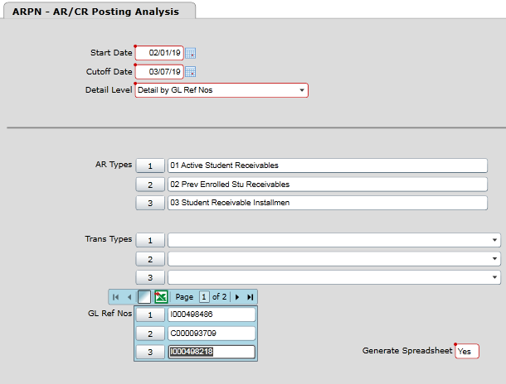
Save all
Change Output Device to H
Save all
Execute in background mode = N
Save all
Wait till you get the download message for your generated download or the actual report. Do not select Finish. This process will run several queries and display several progress bars. When all are finished it will finish and reports will be generated.

Spreadsheet example below
- Be sure your date range covers the GL transaction date
- Multiple ID’s can be entered
- The Acct ID can be used on ARSI/ARTI to find more detail on the transaction
- The Trans No for cash receipts can be used on CRIN to find more detail on the receipt
GL Acct Selected | AR Types Selected | Date | Src | GL Ref No | Trans ID | Acct ID | AR Type | Term | Trans No | Trans Description | AR Subsidiary | Posted to GL | Difference
01_00_000000_11410 | 01 02 03 | 2/18/2019 | IV | I000498218 | 712726 | 0218721 | 01 | 2019SP | 000498218 | Health Service Charge(s) | 20
01_00_000000_11410 | 01 02 03 | 2/18/2019 | IV | I000498218 |  |  |  |  |  |  |  | 20 | 0
01_00_000000_11410 | 01 02 03 | 3/6/2019 | IV | I000498486 | 713790 | 0218461 | 01 | 2019SP | 000498486 | Registration - 2019SP | -5,318.00
01_00_000000_11410 | 01 02 03 | 3/6/2019 | IV | I000498486 |  |  |  |  |  |  |  | -5,318.00 | 0
01_00_000000_11410 | 01 02 03 | 3/6/2019 | CR | C000093709 | 396334 | 0226000 | 01 | 2019SP | 000093709 | Payment, Thank You | -500
01_00_000000_11410 | 01 02 03 | 3/6/2019 | CR | C000093709 |  |  |  |  |  |  |  | -500 | 0

