UPDATING CONFORMANCE REPORTS
- Print GLTB Summary and Detail in “landscape” (at same time because numbers could differ if run on separate days)
- Summary: enter s(summary), month by number, m (monthly) (P2)
- Detail: enter d (detail) (P8)
- Press GL Account Definition Button (P2/P8) to Select List (P3/P9)
- Select List: include 9 under Department and 7 and 8 under Object Code
- Summary and Detail to be sorted by department
- Summary and Detail go out with conformance reports
- The Conformance Report workbooks are found in the Special Programs shared drive. Update “conformance report” workbook using the GLTB summaries. Each grant has its own worksheet within the workbook.
- Make sure “cumulative” includes any added columns
- Added columns need to be reflected under “direct & indirect” worksheet in the appropriate month column for direct expense. This is accomplished by establishing links back to the individual grant worksheets.
- Confirm cumulative totals on conformance worksheets reflect general ledger activity for the period of the grant accurately. Look at detailed GLTB to find difference and update the grant conformance worksheet accordingly. For example, Conformance worksheet and GLTB may differ if Student Payroll, journal entry, or other activity was posted for a previous month.
- After updating all individual grant worksheets, confirm closing balance (last page of GLTB summary) with program direct cumulative in the “direct & indirect” worksheet within the Conformance Reports workbook to insure that the workbook ties to the general ledger.
- Save the Conformance Report file with the name of the month’s activity that was updated. Example: Conformance Reports 2-29-12.
- Print conformance reports after updating in “portrait.”
- Copies of conformance reports with activity for the month go to Principal Investigators and the Sponsored Programs Office with GLTB summary and Detail, updated letter and if applicable, …Verification… for payroll. (See Labor Reports Verification.)
- Conformance Report letters to be updated and printed can be found in the shared drive under “General”.

Setup for GLTB Monthly Summary for Conformance Report
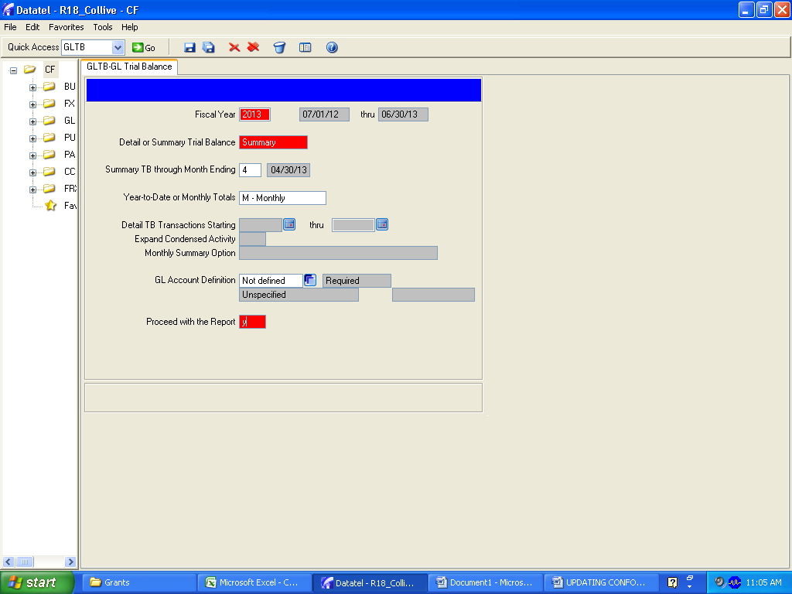

Press Select/List Button
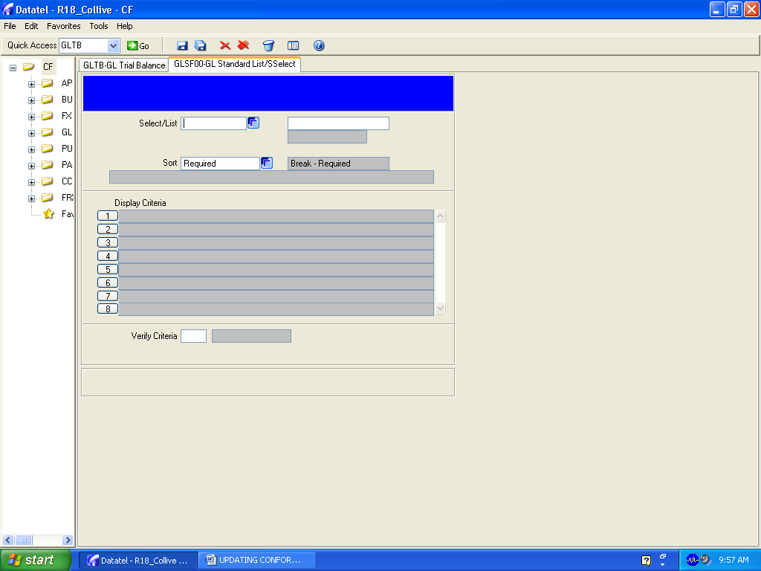

Sample Select List for GLTB Monthly Summary for Conformance Report

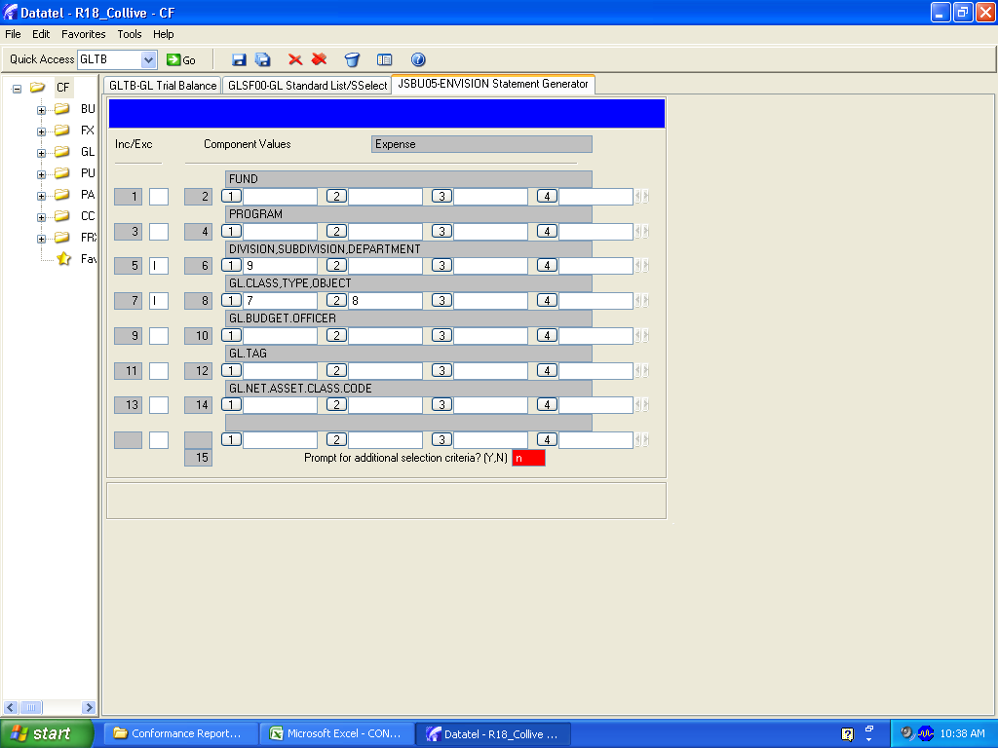

Sample Sort for GLTB Monthly Summary for Conformance Report

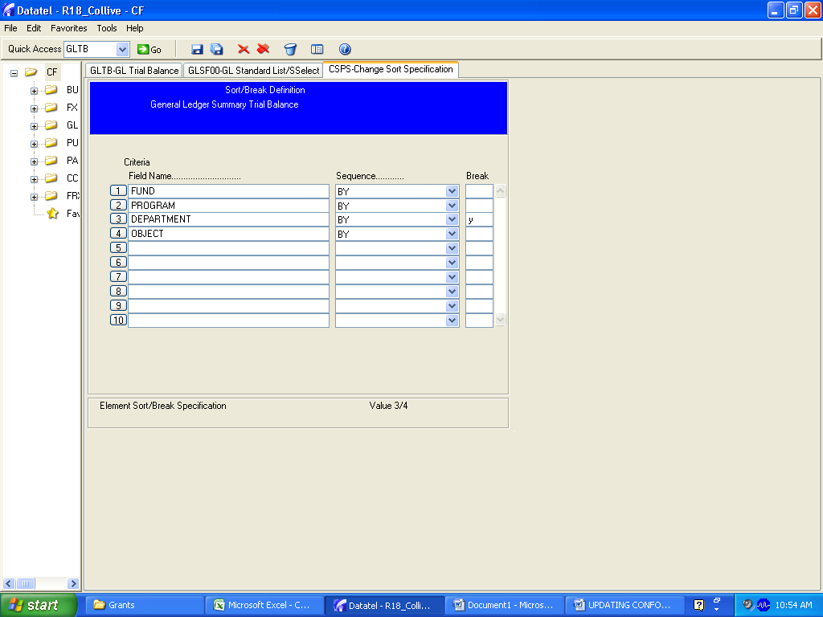

GLTB Report Print Setup
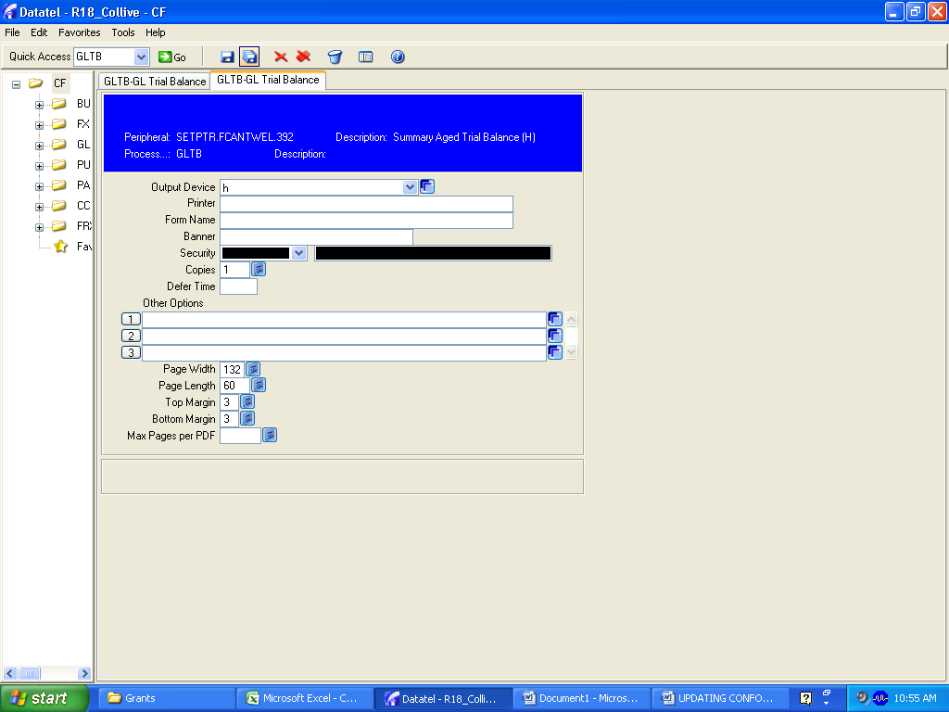

Monthly Summary GLTB p1
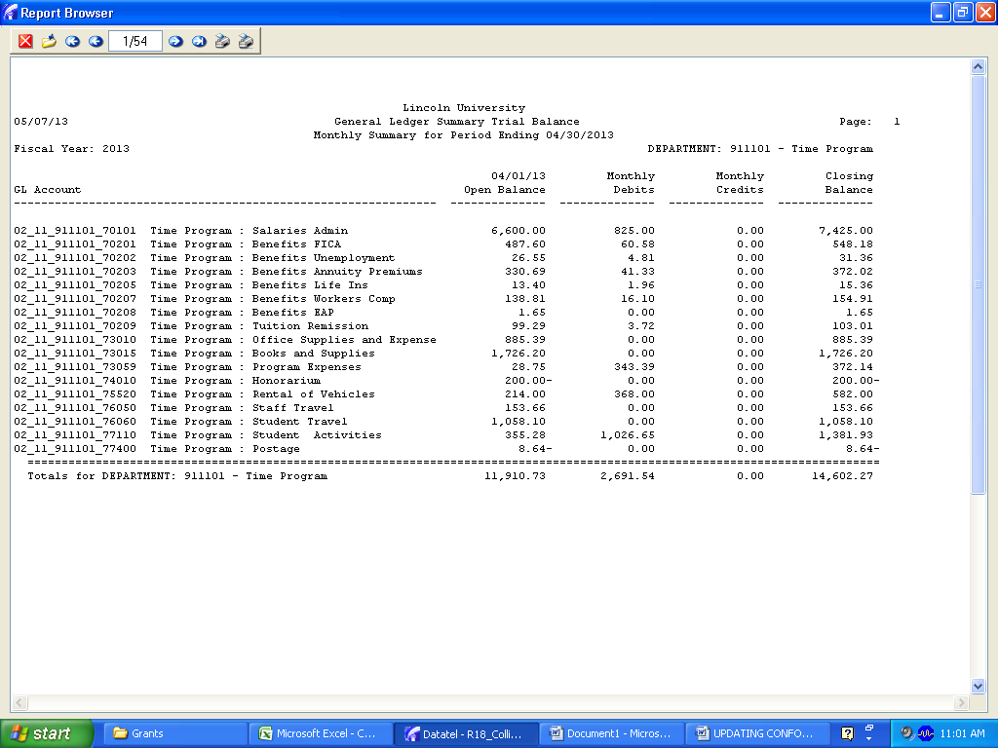

Monthly Summary GLTB Last Page
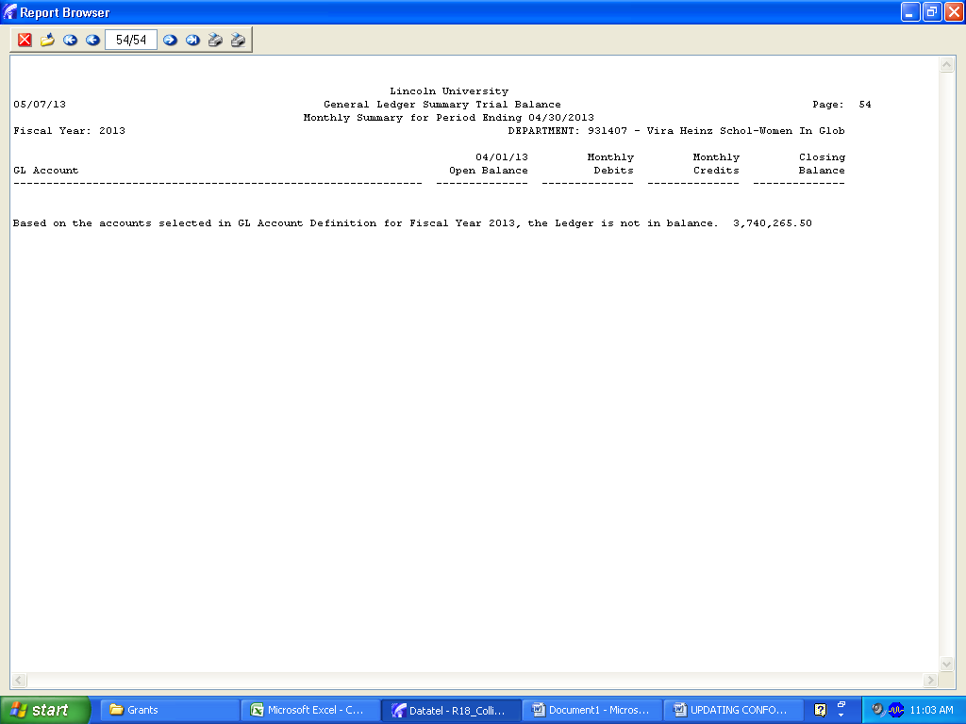

Setup for GLTB Monthly Detail for Conformance Report
