Synopsis
This standard operating procedure (SOP) describes the steps needed in order to change Paycor workflow. The workflow is to update, change an employee’s profile.

Systems Needed:
Paycor
Email
Internet

Internal Departments Impacted:
Payroll
Employees
Human Resources (HR)

- To access Paycor open an Internet search window and enter

- Sign in to Paycor using your Username and Password.

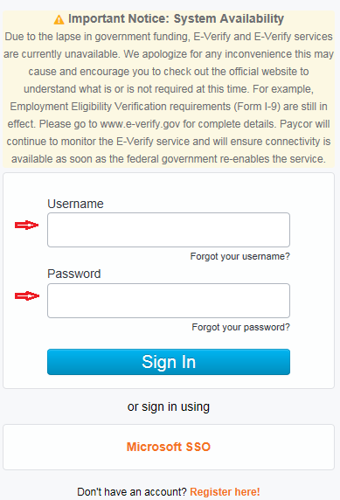

- Click “Employees” then click “Manage Employees”.

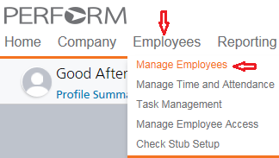

- Enter your employee last name in the search field (red arrow) do not click enter wait for names to populate automatically. Once the name(s) appear use the bar (blue arrow) to scroll down until your employees name is shown, then click your employees name (orange arrow). If your employee name does not appear they could be terminated therefore uncheck “Search Using Filters” (green arrow) and reenter the employee last name in the search field as this will allow terminated employees to populate.

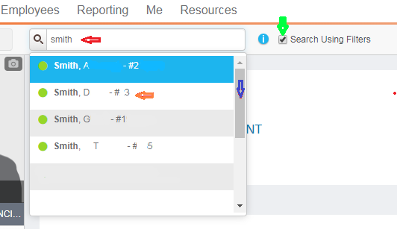

- The color bar (red arrow) indicates if the employee is active (green) or terminated (red).

Active Employee Terminated Employee
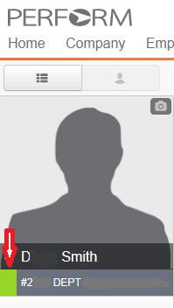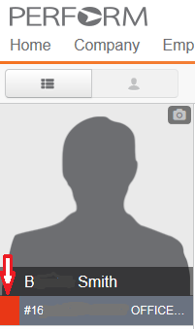

- Click “Company” then “Position”
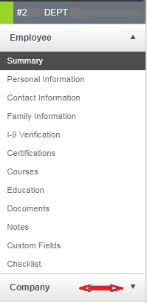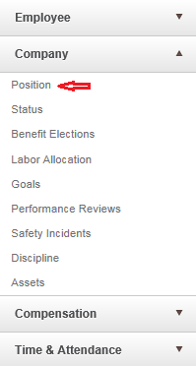

- Position: you may change or update a workflow depending on your needs.
- Job Title: type of position the employee holds
- FLSA : type of level
- Employee Type: type of employment
- Annual Hours: hours the employee works per year
- Department: number and name of the department
- Manager: who the employee reports too
- Status Type: Full Time or Part Time
- Base Shift: is not an active field to update
- Paygroup: how the employee is paid Monthly Staff, Bi-Weekly, Student, Adjunct, 9 Month
- Work Location: where the employee works Main Campus or Graduate Center
- Benefit Classification: FT, PT, Faculty 9 or 12 months, Adjunct, Temporary
- Change Position and Pay: this field is for Human Resources only, send email request to HR

Once you select the field to change or update click “Save” at the bottom right or click cancel if you do not want to save your selection.

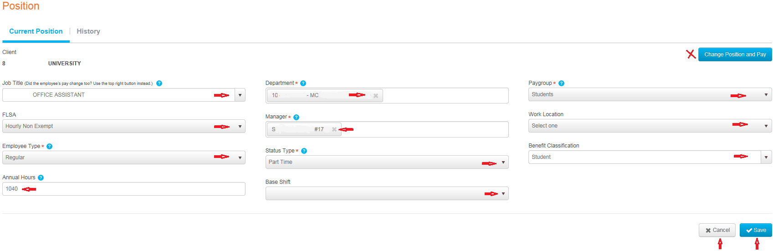

- Click “Status” to review the employee current status active, terminated or on leave of absence.

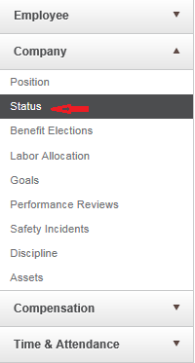

- Status changes or updates are handled by Human Researches send an email to Human Resources with your request. Do not make changes or updates.
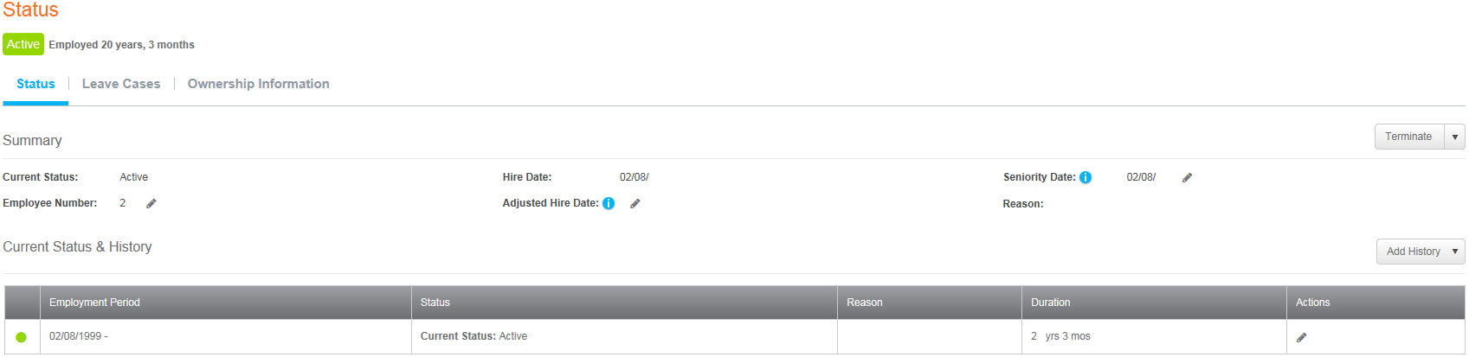

- Click Benefit Elections to review current benefit deductions that the employee requested.
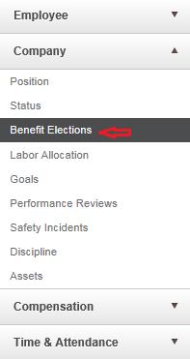

- Benefit Elections changes or updates are handled by Human Resources send an email to Human Resources (HR) with your request. Do not make changes or updates. To review the employees requests the green check marks are what the employee has requested to be deducted from his pay, use the scroll down bar to review all deductions.
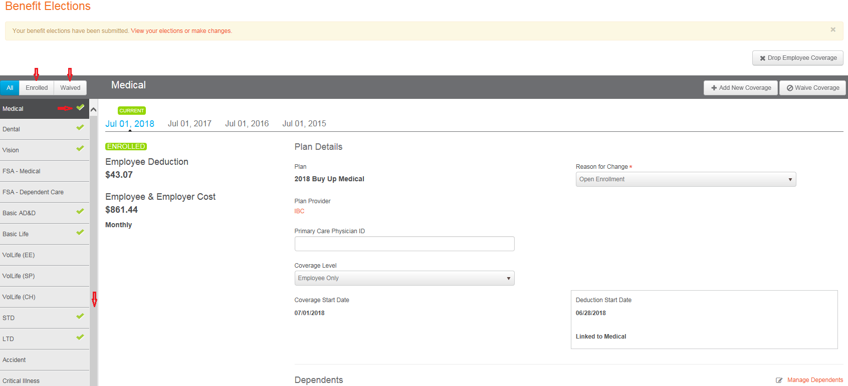
- These fields are handled by Human Resources send an email to Human Resources with any questions.

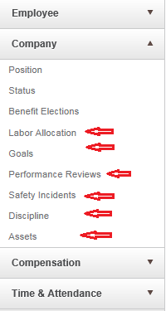

- Click “Compensation” then click either Pay rates or Earnings these fields are handled by Human Resources, send an email to Human Resources with any questions.

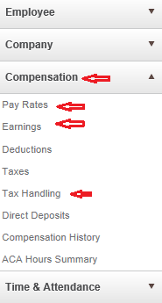

- Click “Taxes” to review, add or change tax information.
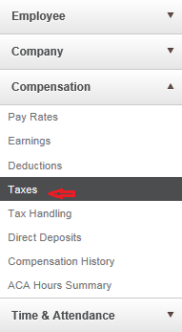

- Depending on where the employee lives they will have different taxes withheld from their paychecks:
- Social Security (SOC) – all employees
- Social Security Employer (SOCER) – all employees
- Medicare Employee (MED) – all employees
- Medicare Employer (MEDER) – all employees
- Federal Income Tax (FITWH) – all employees
- Pennsylvania Unemployment (UNEPA)
- Lower Oxford Twp PA Chester (PALWR) – if the employee works at the Main Campus (MC) and does not live in Philadelphia
- Philadelphia Nonresident (PAPHIN) – if the employee works at the Graduate Center and does not live in Philadelphia
- Philadelphia Resident (PAPHIR) – if the employee lives in Philadelphia

If the tax code deduction is not listed click “Add Tax” (orange arrow) and select the tax code needed.

Click “Calculate” (green arrow) and add a check mark to have the tax deducted withheld from the employee’s next paycheck. Uncheck “Calculate” if you do not want the employee to have the tax code deducted from their paycheck.

To save your changes click “Save” (purple arrow) to save your changes or click “Cancel” if you do not want to save your selections (purple arrow).
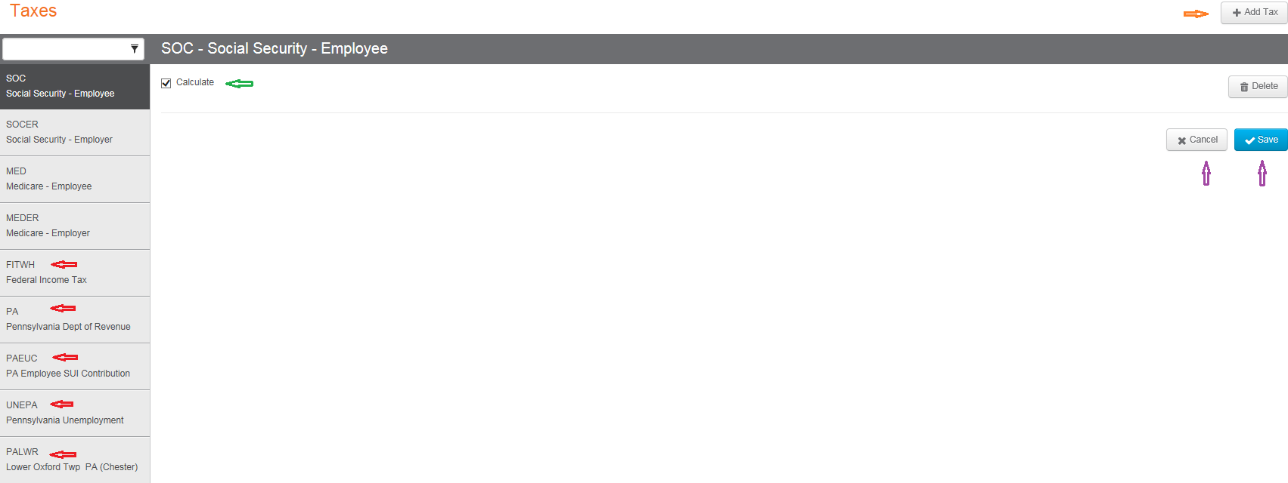

- Click Direct Deposits to review the employee’s checking/savings account information, add or change information.

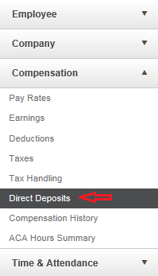

- Click “SHOW” to review the employee whole account number
Click “PRIMARY NET” to view or inactivate the checking or saving account(s)
Click “Add Account” to add checking or savings accounts

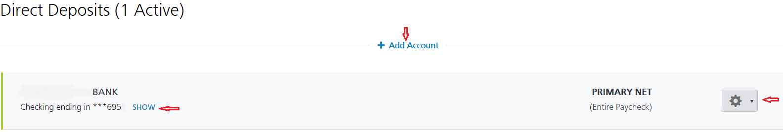

- Click “Compensation History” to review the employees payroll payments, W2,

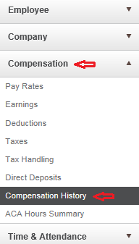

- Pay Stubs will allow you to review the employees past payroll payment.
  - Click the “1” to bring you info a glimpse of the payroll payment
  - Click “View PDF” will show the full payroll payment in PDF format

If you want to void a check you click the “Void” button and follow the prompts.
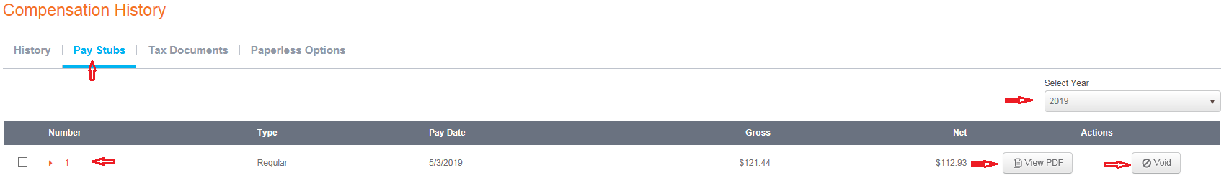

- Click “Time & Attendance” to review the employees PTO accrual activity, setup and work hour settings. Human Resources handles these tabs send an email to Human Resources to requests.

