Synopsis
This standard operating procedure (SOP) describes the steps needed in order to process a payroll adjustment.

Systems Needed:
Email
Excel

Internal Departments Impacted:
Payroll
Employees

- Payroll adjustment request are for employees that need an update or correction to their pay.

- Payroll adjustment request are received through email from:
- Human Resources
- Direct Manager of the employee
- Direct Managers manager
- Payroll Manager(s)

- The email should include:
- Employee name
- Reason for the adjustment
- Date of when the error accrued
- Total hours or dollars to be paid
- Any additional supporting documentation

- Print the email for back-up and add it to the correct payroll folder for the date when you will make the adjustment/payment.

- Access excel:

- Click the payroll folder that you will be making the adjustment/payment
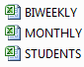
- Add to the adjustment spreadsheet:
- Name: employees name that will be adjusted
- Adj Type: payroll type.. REG, OT, Deduction, Benefits
- Addt’l Total Hours: total hours to adjust
- Total Amount: dollar amount of the adjustment
- Amount Per Pay: if the adjustment is for more than one pay
- # of Pay Period: amount of pay periods the adjustment needs to be adjusted
- End Date: pay period that the adjustment is to end
- Notes: reason for the adjustment

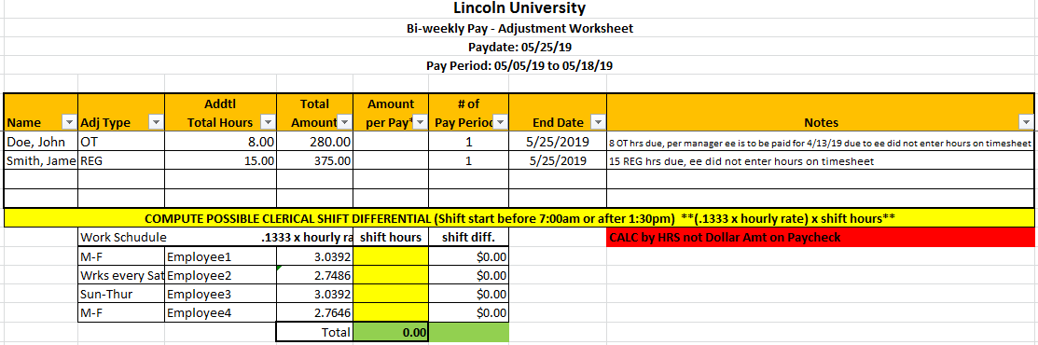

Once you entered the information save the adjustments spreadsheet. Use this spreadsheet the day of payroll is run and enter the information into Payroll Pay Grid. Follow the SOP for the payroll you need.

