Temple University PA CURE- Collaborative Research on Health Care Innovation or Traumatic Brain Injury

Summer Internship Program – Application 2020
Contact Information

Name: _______________________________________________________________________________

Address: ________________________________________________________________________

City: ____________________________________ State: _______________ Zip: __________________

Cell Phone: ___________________________________ Email: _________________________________

Classification: _________________________________________________________________________

Major: _____________________________________ GPA: ____________________________________
(Minimum 3.5)

Essay Question
In a word document please answer the following question: What is the importance of studying traumatic brain injury? (Up to 300 words)

Recommendations:
Request 2 Letters of recommendation from current or past professors. Professors should email the recommendation letters directly to Dr. Patricia Joseph at: joseph@lincoln.edu

Instructions:
The completed application, statement of interest, and resume should be emailed to Dr. Patricia Joseph by February 28, 2020. Professors should email recommendation letters directly to Dr. Patricia Joseph by March 2, 2020.

Applicants will be notified of interview dates on March 09, 2020 through email. Notification of acceptance into the program will be emailed on April 03, 2020.

Temple University will provide select Lincoln University undergraduate students an internship from May 2020 through August 2020. Each intern will receive a stipend.

Project Title: Collaborative Research on Health Care Innovation or Traumatic Brain Injury

To enhance training of minority students in the broad area of neuroscience, with specific training in Traumatic Brain Injury (TBI) and substance abuse, the Temple University PA CURE program has established a training program for Lincoln University undergraduate students. The students selected for the summer internship program will be placed in basic and clinical science labs to learn and research different aspects of traumatic brain injury. This internship will offer students the opportunity to network with medical students, residents, and professionals with in the Lewis Katz School of Medicine.

The students will also participate in intensive research training, mentoring, supplemental didactics, and hands on learning experiences.

The following outlines a typical internship and associated course work:

- Abbreviated coursework/TBI and Substance Abuse
- Attendance at weekly seminars
- Participation in Science Hour meetings
- Data collection and analysis activities
- Laboratory experience, experience with clinical research elements (participant/recruitment screening)

- Library Research

- Interns are required to write and/or orally present reports and provide a detailed evaluation of their internship experiences.

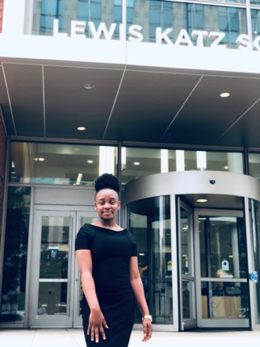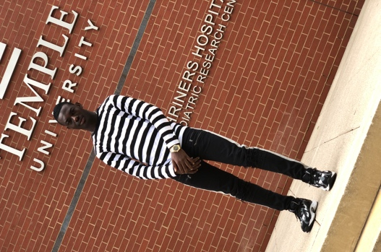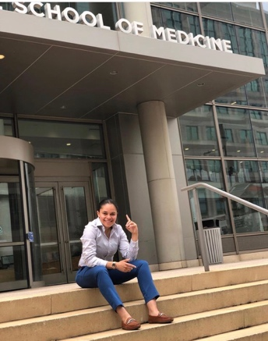
Left to Right: Ayomide Akano (Sr.), Chinwe Eluagu (Jr.), Edwin Nicholas (Jr.), & Siani Perez (Soph.). Summer 2019 Interns.
Edwin Nicholas Summer ’19 Intern
Chinwe Eluagu Summer ’19 Intern
Ayomide Akano Summer ’19 Intern

