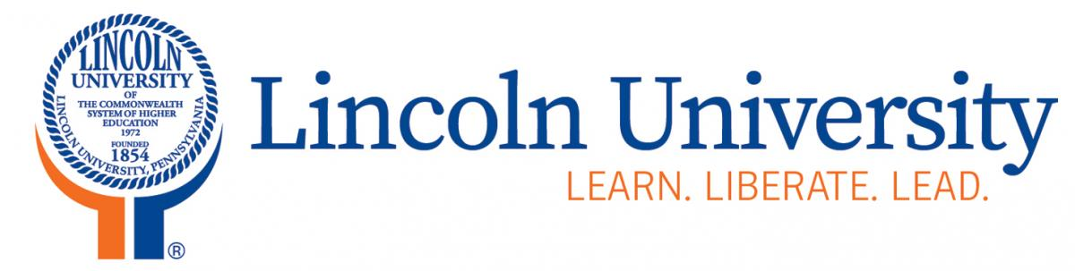
Office of Sponsored Programs

1570 Baltimore Pike
Lincoln University, PA 19352

484-365-7234 phone
484-365-7691 fax
osp@lincoln.edu

MATERIAL TRANSFER AGREEMENT (OUTGOING)

THIS MATERIAL TRANSFER AGREEMENT (the “Agreement”) is made and entered into as of the day of , (the “Effective Date”), by and between Lincoln University of the Commonwealth System of Higher Education, a non-profit Pennsylvania corporation, having an office at 1570 Baltimore Pike, Lincoln University, PA 19352 (the “UNIVERSITY”), and (“RECIPIENT”) having an address at .

In response to the RECIPIENT’s request for the transfer of (“Materials”), from the lab of , UNIVERSITY is willing to provide such Materials, subject to the following terms and conditions:

1. Upon request for a specific quantity of Materials by RECIPIENT, such Materials shall be provided by UNIVERSITY to RECIPIENT, subject to availability of such Materials. The availability of such Materials shall be determined solely by UNIVERSITY.

2. The Materials, and all unmodified derivatives or progeny of the Materials, remain the property of the UNIVERSITY. The Materials shall be used under RECIPIENT’S immediate and direct control only for the research project set forth herein: , or as shown on Exhibit A, (insert research plan here or attach as Exhibit A) within the above identified RECIPIENT. The Materials, and any unmodified derivatives or progeny of the Materials, shall not be used: (a) in any product, (b) for the purpose of producing any product, or (c) for providing any service in which a product or service is sold or otherwise made commercially available. No other right or license, patent or otherwise, is granted to RECIPIENT for the use of the Materials as a result of UNIVERSITY’s transmission of them to RECIPIENT.

3. The Materials shall not be sold, distributed or otherwise made available to any other party for any purpose.

4. The Materials shall be used with prudence and appropriate caution in any experimental work since not all of their characteristics are known. THEY ARE PROVIDED WITHOUT WARRANTY OF MERCHANTABILITY OR FITNESS FOR ANY PARTICULAR PURPOSE OR ANY OTHER WARRANTY, EXPRESS OR IMPLIED. UNIVERSITY MAKES NO WARRANTY OR CLAIM THAT THE MATERIALS WILL NOT INFRINGE ANY PATENT, COPYRIGHT, TRADEMARK OR OTHER PROPRIETARY RIGHTS. Except to the extent prohibited by law, RECIPIENT agrees to release the UNIVERSITY, its trustees, appointees, employees and agents from any liability in connection with use of the Materials by RECIPIENT. Except to the extent prohibited by law, RECIPIENT agrees to defend and indemnify the UNIVERSITY, its trustees, appointees, employees and agents from any and all claims and damages in any way arising from the acquisition, use, storage or disposal of the Materials by RECIPIENT.

5. The Materials will be used in compliance with all applicable statutes and regulations, including NIH guidelines on the use of animals or recombinant DNA. The Materials may not be used for in vivo testing in human subjects. If the Materials are derived from human donors, they shall not be transferred with any individual donor identifying information.

6. This Agreement shall terminate one (1) year from the date on which it was signed, unless terminated or extended through prior written agreement signed by authorized representatives of the parties. Either party may terminate this Agreement prior to the expiration of the designated term by giving sixty (60) days written notice to the other. The obligations of RECIPIENT hereunder shall survive termination. Upon termination, the Materials shall be either returned to UNIVERSITY or destroyed.

7. Upon the execution of this Agreement, RECIPIENT shall be authorized to receive Materials from UNIVERSITY. Requests for specific quantities shall be processed by UNIVERSITY as Materials are available. A shipping cost recovery fee in the amount of $ per (insert cost here if any) will be charged at the time of such shipments.

LINCOLN UNIVERSITY OF THE COMMONWEALTH SYSTEM OF HIGHER EDUCATION

By
Charles M Sutton Date
Director, Office of Research and Sponsored Programs

RECIPIENT OFFICIAL

By
Authorized Individual for the Institution Date
Printed Name:
Title:

Read and understood by RECIPIENT INVESTIGATOR

By
Recipient Investigator Date
Printed Name:

