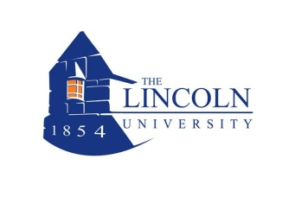

**THE LINCOLN UNIVERSITY**

**OFFICE OF STUDENT SUPPORT SERVICES**

**DISCIPLINARY SANCTION COMMUNITY SERVICE PROGRAM**

**POST-REFLECTION SUPPLEMENT**

Name: Date:

1) What were your violations (s)?

2) How has your attitude and behavior changed since enrolling in D.S.C.S. Program?

3) What are some of the things you learned from the Reflection Meetings?

4) Of all the D.S.C.S. workshops you attended, which ones did you like most and why?

5) Did you attend the Anger Management Workshop Series ⁭Yes ⁭No?

If yes, how many did you attend______

If yes, what did you learn about yourself?

6) Did you attend the Drug and Alcohol Workshop Series⁯ Yes ⁯ No?

If yes, how many did you attend______

If yes, what did you learn about yourself?

7) Did your D.S.C.S. experience change your understanding of the student judicial affairs code of student conduct?

8) What was your best experience in D.S.C.S.?

9) How did D.S.C.S. help you in becoming a better representative of a Lincoln Man or Woman?

10) What can we do to improve the D.S.C.S. Program?