Email Signatures
Every email you send from a lincoln.edu address communicates the Lincoln University brand. Having consistent email signatures across users — just as printed business cards are consistent — communicates that the workforce is professional and coordinated. Please review the signature options and examples on the following pages, decide what fields you want to include, then substitute in your information based on the template provided on page 3.
EXAMPLE MINIMUM SIGNATURE
John Smith Lincoln University Office: 484-365-8000

See page 4 for full signature options.

Fields to Include

Required
- Name
- Lincoln University
- Phone number

Recommended
- Pronouns
- Position or title
- Unit, department, or office
- Division
- 1570 Baltimore Pike, Lincoln University, PA 19352
- lincoln.edu

Optional
- Building and room number
- Fax number
- Additional phone numbers
- Email
- Unit, department, or office URL
- Social media

Name Section
- Recommended Font: Calibri (If Calibri is not available, use Arial or basic sans serif font.).
- Recommended Color: Blue (In Outlook, choose "dark blue text 2").
- Format: Bold
- Size: 11 or the same size as the body content. Do not exceed 12.
- Left aligned.

Title and Contact Information Section
- Recommended Font: Times New Roman.
- Recommended Color: Black
- Format: Regular, except for your title, which, if used, should be italicized
- Size: 9 or a one-point size smaller than the name
- Breaks: A hard return should define name/title, location, phone, and digital information.
- Left aligned.

Courtesy Titles & Academic Degrees | Courtesy titles (e.g., Mr., Ms., Mrs.) and academic degrees are optional. Do not use both "Dr." and "Ph.D." or "Ed.D." Adding "Ph.D." or "Ed.D." is preferred over "Dr." to be clear as to the degree.

Spacing | Line spacing is 1.

Titles | If you have more than one official title (e.g., director and professor), place the primary role first, followed by the secondary title.
Example:
Tom Smith
Professor, Department of X
Director, Special Program
To shorten the signature's overall length, you may put your title (in italics) and unit name (not italicized) on the same line divided by a comma if space permits.

Unit Names | Use the formal name of your unit, department, or office.
Examples:
  - Department of Mathematical Sciences, Not: Math Department
  - Department of Business and Entrepreneurial Studies, Not Business Department
  - Office of Career Services, Not Career Services
  - Office of the Bursar, Not Bursar's Office

Cabinet-level Units | Use the formal name.
  - Division of Academic Affairs
  - Division of Student Success
  - Division of Finance & Administration
  - Division of Human Resources
  - Division of Institutional Advancement
  - Department of Athletics & Recreational Services

Email and Web Address | Underline and hyperlink email and web addresses. When possible, change the color to black rather than blue.

Labels |Use capitalized words to label contact fields. Only a phone number is required, but if more than one label is included, they must be ordered: Office, Direct, Cell, Fax, Email, and Website. If only one phone number is listed, the words "Office" or "Direct" are optional.

Logos | It is recommended that you do not include the logo or any graphics. They are commonly blocked for security reasons. If desired, the wordmark or modified seal are acceptable (do not use both); they should be placed left aligned immediately after the last line of signature text and should not be taller than the signature text's combined height.

Social Media | Social media accounts may be added as the last line, as shown in the example below. Do not include images for each of the platforms. You may change the URL to the official accounts of your unit.

Taglines | If your unit wants to add a motto after the email signature, all unit members should use it for consistency. Do not include personal quotes or inspirational sayings.

Confidentiality | If necessary, include confidentiality and other disclaimers depending upon your position and department needs. If multiple people in your unit use disclaimers or notices, be sure they are consistent. Place the notice in black, two lines under your email signature, and one-point smaller than the body copy of an email.

How to add your signature in Office 365:
- Open your Office 365 email account
- Go to Settings (gear icon)
- Scroll to bottom and click View all Outlook setting
- Click on Compose and reply, and add your Email signature

How to add your signature in Office 2016:

- Open a new email message.
- On the Message menu, select Signature > Signatures.
Depending on the size of your Outlook window and whether you're composing a new email message or a reply or forward, the Message menu and the Signature button might be in two different locations.
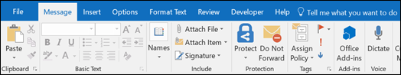
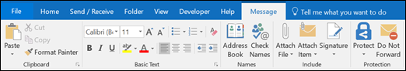
- Under Select signature to edit, choose New, and in the New Signature dialog box, type a name for the signature.
- Under Edit signature, compose your signature. You can change fonts, font colors, and sizes, as well as text alignment. If you want to create a more robust signature with bullets, tables, or borders, use Word to format your text, then copy and paste the signature into the Edit signature box. You can also use one of our pre-designed templates for your signature. Download the templates in Word, customize them with your personal information, and then copy and paste them into the Edit signature box.
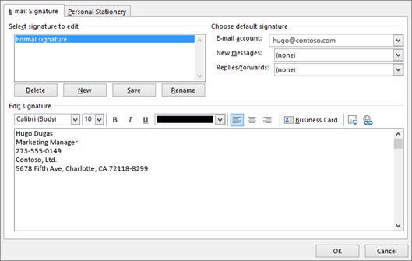
Notes:
  - You can add links and images to your email signature, change fonts and colors, and justify the text using the mini formatting bar under Edit signature.
  - You can also add social media icons and links in your signature or customize one of our pre-designed temlates. For more information, see Create a signature from a template.
Updated 3/30/21

 | FULL SIGNATURE
Vertical Version |  | Horizontal Version
Jane Doe |  | Jane Doe
Department Assistant  Office of Communications & Public Relations Division of Institutional Advancement Lincoln University |  | Department Assistant  Office of Communications & Public Relations Division of Institutional Advancement Lincoln University
International Cultural Center, Room 212 1570 Baltimore Pike  Lincoln University, PA 19352 |  | 212 International Cultural Center 1570 Baltimore Pike  Lincoln University, PA 19352
Office: 484-365-8000  Direct: 484- 365-8000  Cell: 484-365-8000  Fax: 484-365-8000 |  | Office: 484-365-8000 | Direct: 484-365-8000  Cell: 484-365-8000 | Fax: 484-365-8000  lincoln.edu | lincoln.edu/communications Facebook | Twitter | Instagram | LinkedIn | Flickr
lincoln.edu lincoln.edu/communications
Facebook | Twitter | Instagram | LinkedIn | Flickr
John Doe, Ph.D. |  | John Doe, Ph.D.
Professor and Chair Department of Biology Division of Academic Affairs Lincoln University |  | Professor and Chair Department of Biology Division of Academic Affairs Lincoln University
Ivory V. Nelson Science Center, Room 212 1570 Baltimore Pike  Lincoln University, PA 19352 |  | Ivory V. Nelson Science Center, Room 212 1570 Baltimore Pike  Lincoln University, PA 19352
Office: 484-365-8000  Direct: 484-365-8000  Cell: 484-465-8000  Fax: 484-365-8000 |  | Office: 484-365-8000 | Direct: 484-365-8000  Cell: 484-365-8000 | Fax: 484-365-8000  lincoln.edu | lincoln.edu/biology  Facebook | Twitter | Instagram | LinkedIn | Flickr
lincoln.edu lincoln.edu/biology
Facebook | Twitter | Instagram | LinkedIn | Flickr
Mr. John Smith |  | Mr. John Smith
Director, Office of Career Services Division of Student Success Lincoln University |  | Director, Office of Career Services Division of Student Success Lincoln University
Wright Hall, Room 212 1570 Baltimore Pike  Lincoln University, PA 19352 |  | Wright Hall, Room 212 1570 Baltimore Pike  Lincoln University, PA 19352
Office: 484-365-8000  Direct: 484-365-8000  Cell: 484-365-8000  Fax: 484-365-8000 |  | Office: 484-365-8000| Direct: 484-365-8000 Cell: 484-365-8000 | Fax: 484-365-8000  lincoln.edu | lincoln.edu/careerservices Facebook | Twitter | Instagram | LinkedIn | Flickr
lincoln.edu lincoln.edu/careerservices
Facebook | Twitter | Instagram | LinkedIn | Flickr

