How to delete an account that has never been used (GLDL)
For the purpose of this example I first created a new account to be deleted (01-00-000000-80030 - Test)
ALWAYS VERIFY THAT THERE HAS BEEN NO ACTIVITY SINCE THE BEGINNING OF COLLEAGUE (DATATEL.) ANY HISTORY WILL BE DELETED.

- First – Type “GLDL”

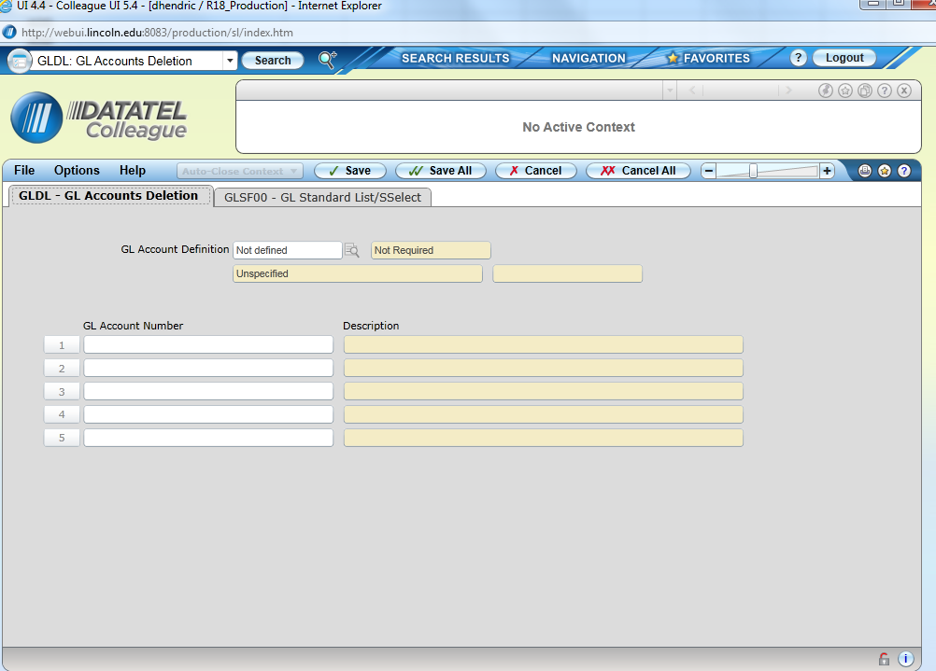

- Next detail in to “GL Account Definition” by clicking on the magnifying glass.
- Then populate the Fund, Program, Department and Object Fields. (See Below)
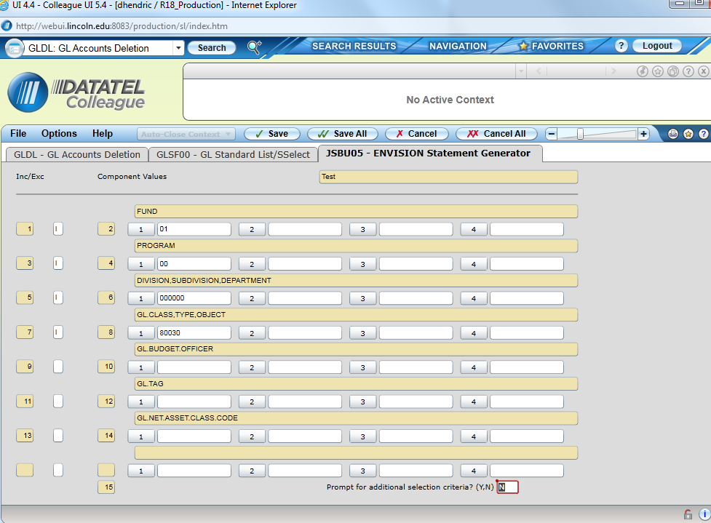

- After entering the account detail hit “Save All.”
- This will bring you back to the main screen and show the account to be deleted.
Note that in this example we’re only deleting a single account. If we wanted to delete all accounts in a particular department, simply leave the other fields undefined. CHECK THE LIST ON THE MAIN SCREEN BEFORE PROCEEDING WITH DELETION.
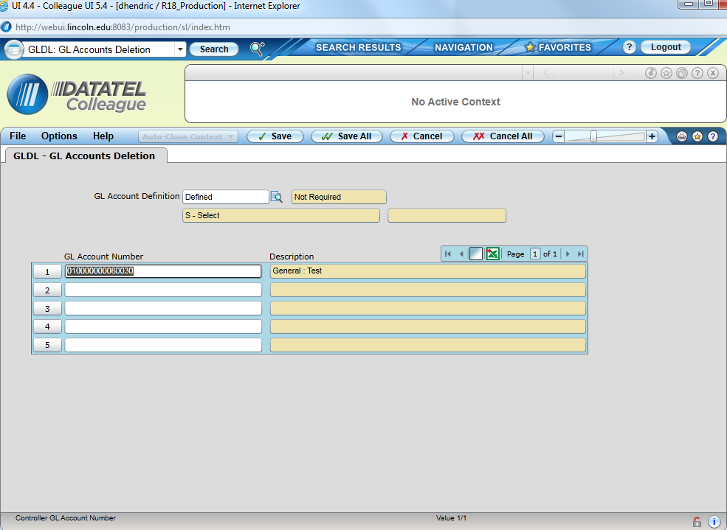

- Select “Save All”
- A confirmation screen will appear to confirm deletion (see below.)

