Current And AP Account Bank Reconciliation Procedure
- Obtain Copy of “Month – XX Bnk Rec” file from Business Office Financial Assistant. This File has a tab for each day, matching the cashier’s deposits to the bank account. Use the Tab “Final Findings” (Copy this to another spreadsheet) to serve as a starting point for reconciling. The far left columns are Bank Activity. Columns to the right of this are the corresponding activity posted to the GL via either a Journal Entry or a Cash Receipt. To the right of the GL Activity, insert 3 Columns and Title them “Per GL”, “Per Bank” and “GL vs Bank.” Create a Formula for “Per GL” equal to the sum of the GL activity in that line. Create a formula for “Per Bank” equal to the bank activity column for that line. Create a Formula for “Bank vs GL” equal to “+ “Per Bank”-“Per Gl.” To the right of this, create columns to explain the variance between Bank and GL.
- Run a GLTB for 01-00-000000-11010, export it as text and import it into Excel.
- Print out the Daily tabs from the “Month – XX Bnk Rec” file for use in matching GL activity to Bank Activity.
The Above now provides the tools necessary to reconcile the GL to the Bank
- Using the Daily sheets printed out in step 3, enter/verify the GL activity corresponding to the bank activity and tag each CR or JE on the sheet created in step 2 with a bank date (What’s left at the end of this exercise, on the sheet described in step 2, are in-transit items and possibly a handful of other items to be investigated.)
- Variance items in the “Bank vs GL” column (step 1) should be explained on columns to the right. Common/Recurring variances are as follows:
- Cash Link A/P – The AP account draws off of the current account to cover checks clearing through the bank. This Entry is made as part of the reconciliation process between the AP account and Current Account
- Internal Sweep Activity – Each day the non-interest bearing Current Account balance is swept into a commercial paper account which is attached to the account. This Commercial Paper Account is reconciled in conjunction with the Current Account and is thus not a reconciling item between bank and GL.
- Deposits in Transit Clearing from the prior month
- Cash Deposited to the AP Account – Remote deposits of checks thru the end of June 2012 had been deposited into the AP Checking Account (a -0- balance account) many of which are recorded to the Current Account Creating Offsetting variances between the 2 accounts
- Deposits in Transit for the current Month – Note, some of these deposits in Transit relate to transfers to and from the temp restricted and endowed bank accounts. For this reason, the Temp Restricted and Endowed Bank Accounts (As well as the Payroll account which draws off the current account to cover checks, drafts, and taxes) should be reconciled prior to completing the AP and Current Account Reconciliation
- Any items remaining from step 4 now need to be added to the bottom of the reconciliation spreadsheet (In Transit and other Items)
- Now that All bank and GL items have been accounted for, a proof should be prepared proving this (At the bottom of the sheet):
- Net the beginning and ending balance and verify this equals the bank activity on the spreadsheet
- Net the monthly debits and credits to the GL and verify that this ties to the GL activity on the spreadsheet
- Net the Bank Activity vs the GL Activity and verify that this ties to the total of the variance Columns
- Use the now proved out spreadsheet to complete the Current Account Bank Rec Form for the month. Document all reconciling items and support them with Bank and GL source documents.
AP Bank Reconciliation
Reconciling Cash Receipts to the AP Account
- Run a GLTB for 01-00-000000-11018 and export as text, then import into excel. Data Sort the Output by Transaction Type/By Date, then copy the CR Activity to a separate sheet.
- Sum the GL Receipts by day and create a GL column for the daily Sum.
- Create a Column for Daily Bank Deposit
- Create a Variance Column and Compare Bank vs GL
- Identify the variances on the AP account that offset the deposit variances on the Current Account (This will be the majority of your variances, and will require an entry between the Current and AP GL Accounts.) What remains will likely be checks and money orders cashed thru petty cash and deposited in the bank. For these, a journal entry will be necessary with a CR to Petty Cash and a Dr to the AP Account. Any remaining cash receipt variances will need to be isolated and investigated.
Reconciling Cash Disbursements
Outstanding checks clearing the bank are cleared in Datatel using the following Process
- VERIFY ALL PDF O/S REPORTS ETC. SAVED FROM PRIOR MONTH (Very important – once checks have been cleared for a given month, outstanding check reports for the prior months can no longer be generated.
- Rename the last months file in the bank rec shared folder from “LIU19426” to “month – YYYY”
- Go to MS Access and “Archive Fulton Records” (last button)
- Go to Fulton Bank and click “browse” on AR output tsfr (fts.fult.com)
- Put file in bank rec root (shared drive)
- Click”OK”
- Click “Download”
- Go to Windows Explorer

- Find “liu19426” file and rename to add txt to extension
- Go to Access
- “import Fulton” – Use month end date
- Print Report Paid Checks
- Print report cks other status
- Export file to Collegue (click)
- Go to Collegue
- Enter bank code “07” (for AP) (LBRT – Load Bank Reconciliation Data)
- Select Save All (Note – no report will print)
- Type “RCFT” Enter Month End Date
- Save All
- Print and save report
- Run SCKR for all categories (void/OS/Reconciled)(Run OS separately starting 4/1/10 and save as a pdf – print for reconciliation) (Then run wide open and save as txt and pdf – don’t print due to size.)

SCKR Steps
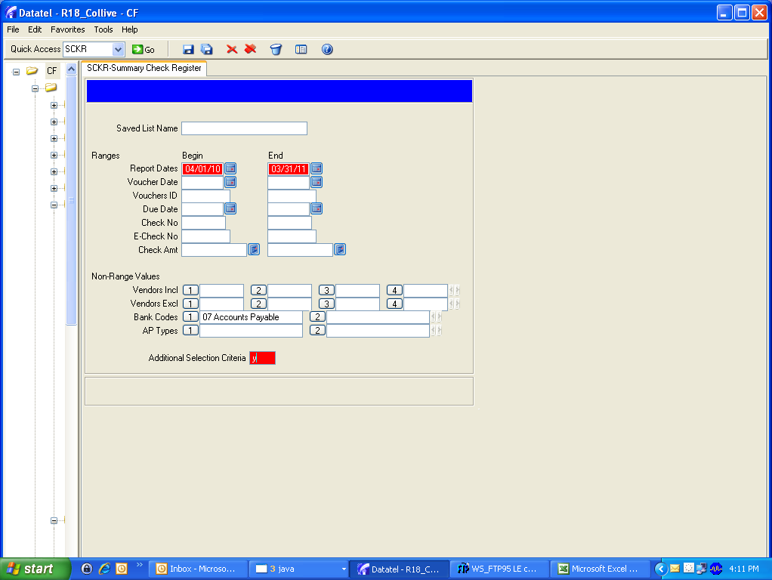
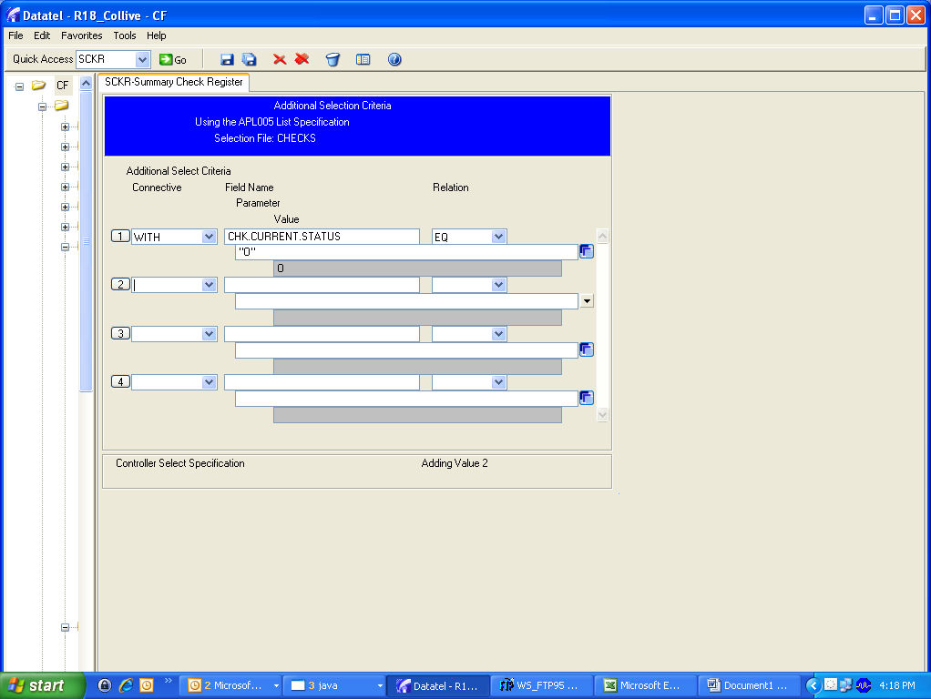

With the above additional selection criteria, you will print only outstanding Checks

Answer “no” to additional selection criteria to get a complete list of all statuses.

- Run VCRG to generate a list of voided checks. (Note: Run VCRG with report date 01/01/10 to current month – Enter the dates only, but don’t enter a bank code.)
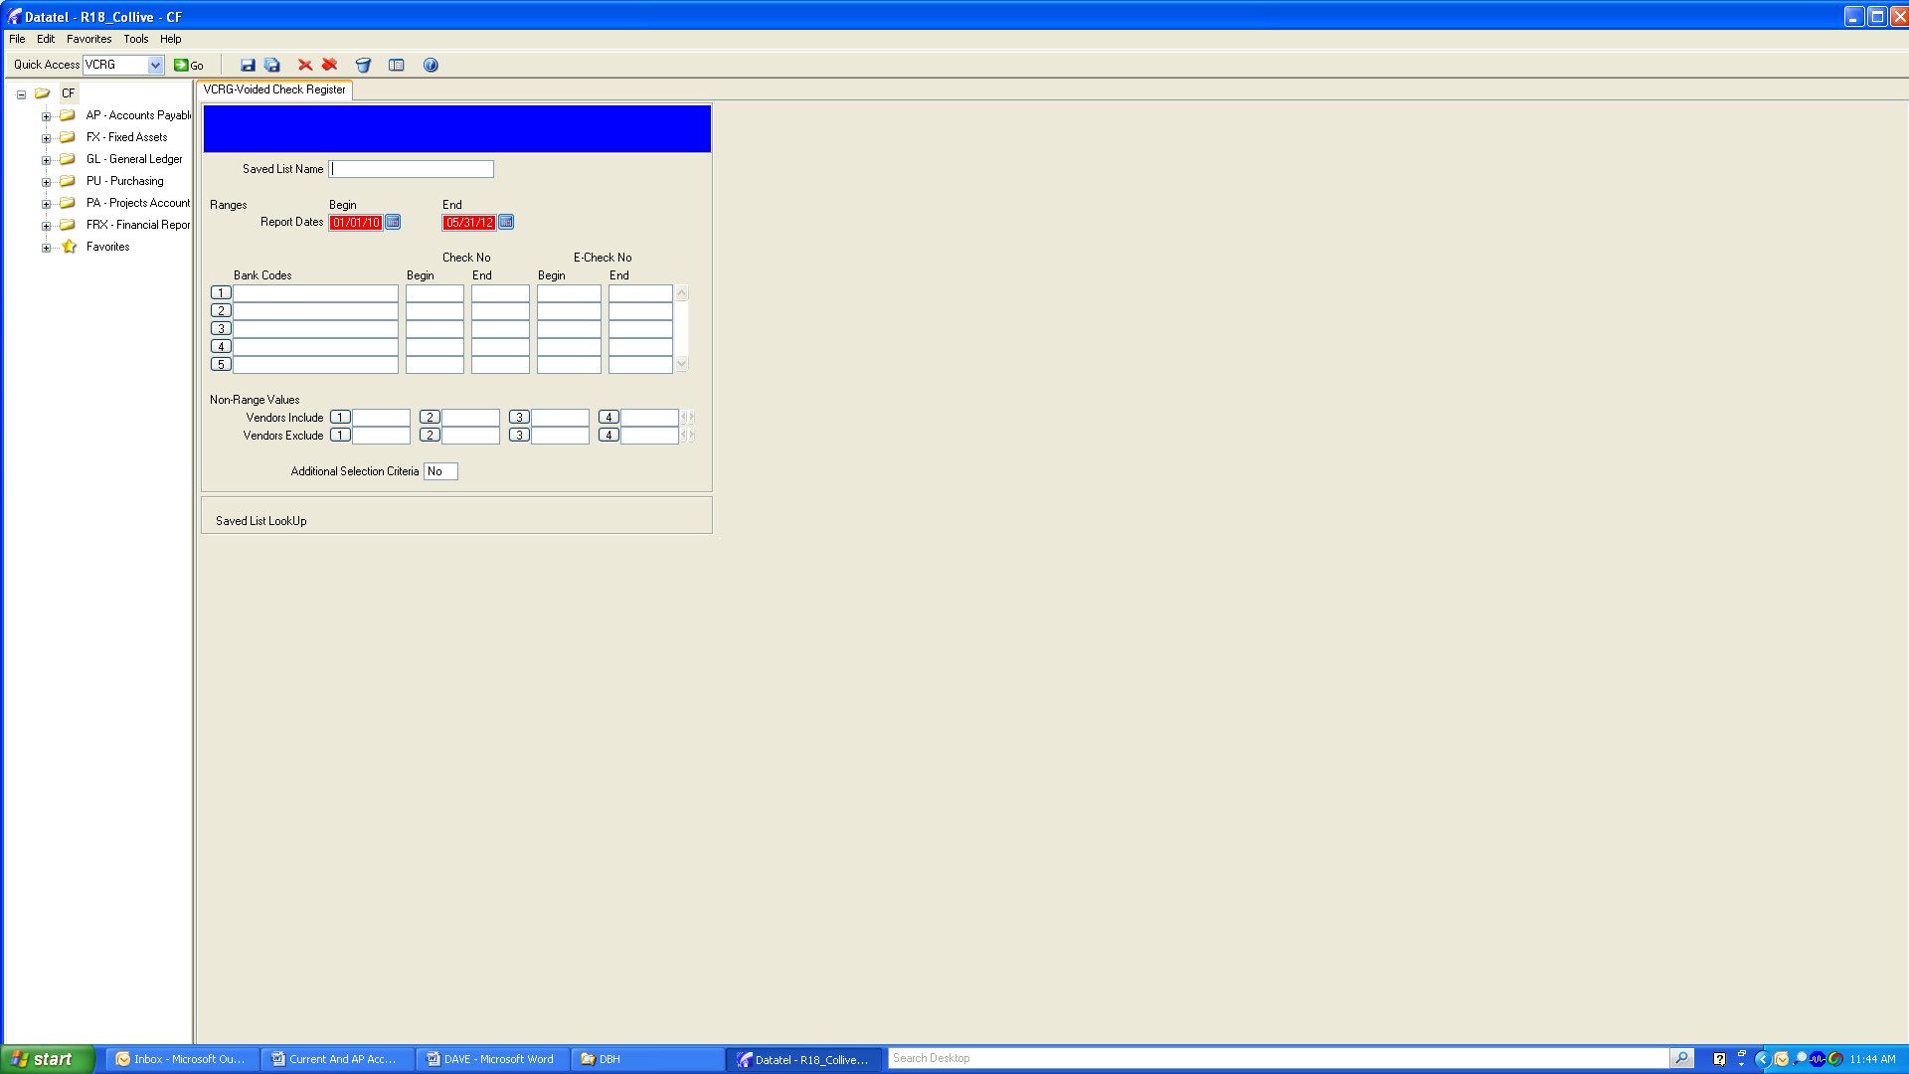

Now that the checks have been cleared electronically and all reports generated, the final outstanding check list can be prepared, by doing the following:
- Print the pdf of outstanding checks generated by SCKR
- Print the Void Ck Register created by VCRG
- Make a Copy of the Unpaid Checks Report from the AP Bank Statement
The purpose of the above is to reconcile the Bank O/S Checks List to the Datatel O/S Checks List by doing the following:
- Verify cks from the prior month’s reconciliation that were O/S on the Bank and NOT O/S on the GL still have the same status (Note: Any item on the bank with a code “4” next to it has had a stop payment issued and is not included on the Bank’s O/S balance. Stop payments issued during the current month but cut in a prior month could affect this.)
- Identify Checks on the VCRG Report that were voided during the month being reconciled that show as outstanding on the bank. Add these to the list from the prior month’s reconciliation “General Leger Voids Sent To Bank”
- Identify Checks on the VCRG Report that were voided between the month end date of the reconciliation and the date of the generation of the VCRG and SCKR report. Show these on the bottom of the OS Checks reconciliation under “Outstanding at Month-XX not included in balance”
- Enter the O/S Balance Per Bank from the Bank Unpaid Checks Report
- Edit the Formula for O/S Balance Per GL and enter the current month O/S Checks from the GL Report (Note: The formula automatically backs out checks identified in step 3.)
- Verify that the test in cell 5E = -0- (investigate and resolve if it doesn’t)
Finalize the reconciliation on the MMMM YYYY tab
- Update Dates
- Update Bank Deposit and Withdrawal amounts (Same – yielding -0- bank balance)
- Verify that the O/S Checks are feeding correctly from the O/S Checks Tab
- Enter the Reconciliation Month GL Ending Balance
- Enter Reconciliation items identified during the analysis of cash receipts Bank vs. GL between the GL Balance entered in step 4 and the adjusted GL Balance at the bottom of the reconciliation.
- Verify that all entries between the Current Account and AP account offset.
Your reconciliation is now complete.

NOTE: The Current and the AP account (Fulton Bank) are (along with most other Fulton accounts) being transferred to PNC Bank (1/1/15-6/30/15.) The PNC Operating Account will replace both the Current and AP accounts. This will eliminate the zero balance AP account currently used at Fulton. The reconciliation methodology will remain the same with the exception of the cash to cash transfers between the AP and the Current account.

