Monthly Benefit Allocation Procedure

- Start with the monthly Labor Distribution Report (From the payroll manager)
- Copy the monthly tab into a new tab (to preserve integrity of original)
- Copy the department # above each subtotal down to the subtotal line (you’ll need this so you can see department numbers when you collapse to just subtotals)
- Name a new tab “wage subtotal by department”
- Collapse the subtotals to subtotals only
- Create a new tab and label “dept sort and flag NA”
- On Wage subtotal tab in excel use “go to” “special” “values” and then copy the subtotals only to a new “dept sort and flag NA” tab
- Remove Department “000000” and Departments “9xxxxx” from the subtotals and re-sum without those departments. (This becomes the basis for the spread.)
- Insert a new tab and name “allocate”
- Copy the “Dept Sort and Flag NA” tab into the “allocate” tab and setup in the same manner as the completed example spreadsheet shown at the bottom of this procedure (note that you can save yourself some time on this sheet by copying portions of the same tab from the prior month)
- Run a GLTB for 01-15-510001-70202…70206…70207…70209 This will generate what needs to be distributed.
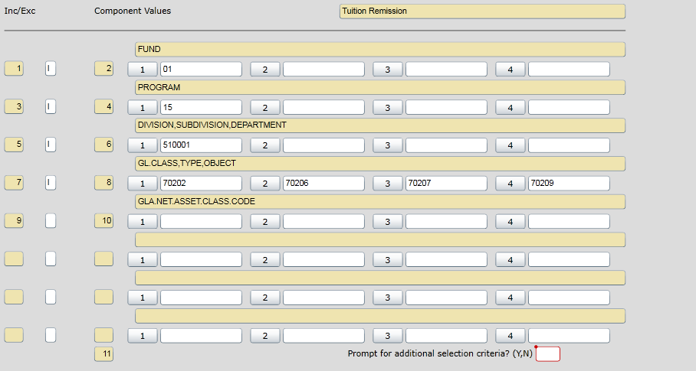
- Distribute the net expense activity in each of the 4 accounts using the allocation tab (note that the formulas are set up to round to 2 digits after the decimal point. You may need to plug a penny or two to balance to the GL amount)
- Create a new tab and label “allocation values”
- Copy the “allocation” tab to the “allocation values” tab by pasting “values” and “formats”
- Copy the JE tab from the prior month or from the example below.
- Build the new JE in the same format as the prior month. Do this by copying and pasting from the upload format columns from the “allocation values” tab (Note: This tab is set up in a format ready to be uploaded….Don’t change column widths or formatting.)

Here is the completed Allocation entry.

Upload the JE using the following steps (Below)

How to Upload JE’s
- Setup excel upload in proper format (See format at end)
- Save as excel for future
- Delete top row
- Save as formatted Text – Space Delimited (Say OK to excel warning)
- Close file – Don’t save…..you already did (could mess things up)
- Go to Colleague Enter FLUL
- Target Directory = GL.Interfaces (Will come up in all caps)
- Target File Name = Same as file name….include prn extension (Can’t Exceed 25 Characters)
- Execute Upload = Yes
- Update
- Select File
- Browse and Select Formatted File
- Should Say “File Upload Complete”
- Go to GLID (Caution there may be other users using this….which could cause a problem)
- GL Interfaces Def Lookup = JEIMPORT
- Default File Name = Name of Import File
- Save ALL
- GLIM
- GL Interfaces Def Lookup = JEIMPORT
- Verify that the file that shows up is yours
- Import Mode “report only”
- OK to proceed = Y
- Save all
- Save PDF of Validation Report and Review
- Close Validation Report in Colleague
- GLIM
- GL Interfaces Def Lookup = JEIMPORT
- Verify that the file that shows up is yours
- Import Mode “Update from Report”
- OK to proceed = Y
- Save all
- Save PDF of Final Import
- Run PGLT…..Note there may be more than one…..JE’s break at roughly 200 Lines

Proper Format
FIELD | START POS | LENGTH | COMMENT
SOURCE CODE | 1 | 2
GL ACCOUNT NO | 3 | 15 | no hyphen or underscore, include leading zero
DEBIT AMOUNT | 18 | 12 | no decimal
CREDIT AMOUNT | 30 | 12 | no decimal or minus sign
DESCRIPTION | 42 | 30
REFERENCE NO | 72 | 10
PROJECT NUMBER | 82 | 15
TRANSACTION DATE | 97 | 8 | MM/DD/YY format
Text file name limited to 25 characters
Text file name - first letter must be uppercase

