Synopsis
This standard operating procedure (SOP) describes the steps needed in order to clear Paycor Critical Errors for the bi-weekly and student payrolls. The bi-weekly and student payroll run twice a month with the exception of two months that have three payrolls.

Systems Needed:
Paycor
Excel
Email
Internet

Internal Departments Impacted:
Payroll
Accounting
Employees
Human Resources (HR)

- To access Paycor open an Internet search window and enter

- Sign in to Paycor using your Username and Password.

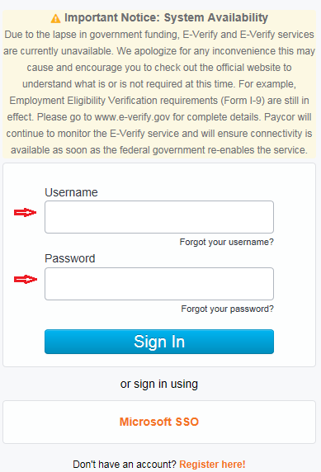

- Click “Employees” then click “Manage Time and Attendance”.

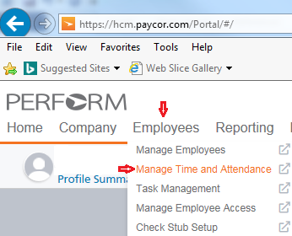

- Select the “Group” down arrow and click the pay period to be processed. Which you will need to review the “Previous Period” for processing. You will use this process for Bi-Weekly and Student payrolls by changing the “group” to the payroll you need.

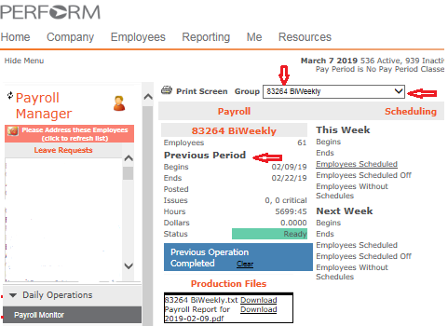

- Click “Daily Operations” and then click “Payroll Monitor”.

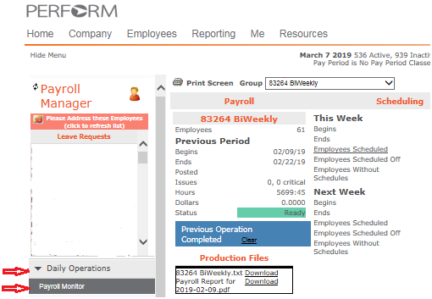

- “Issues” are what needs to be corrected. These are caused by an employee missing a punch on a time-card or an absence that needs to be acknowledged. The number listed next to “critical” are the number of errors that need to be resolved. Click on critical errors report continue to step 7. For “Dollars” this is due to a supervisor entered hours in a date field that is before the employee started working. If there is a number higher than 0.0000 click the number this will take you to the “dollars” error. Proceed to step 10.

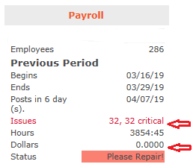

- Click “Excel” to download the report to verify “exception errors”.

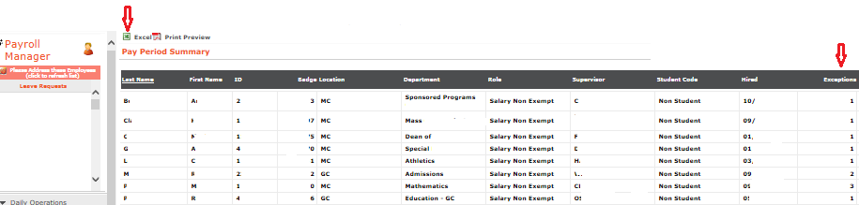

- Click “Open” to review the Excel report.
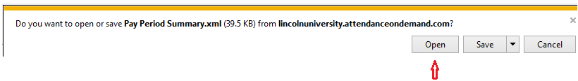

- Review the excel report for errors shown in the “Exceptions” and “Condition” columns. Sort the report to show Last Name, First Name, Supervisor, Exceptions and Condition and send emails to the employee’s supervisor advising to correct the timesheet error for missed punches and absent requests. All errors need to be corrected before you can process the payroll. If errors are not being corrected you should try to call the manager and send a follow-up email. If all errors do not get corrected and you have attempted by email to have the error correction you will need to delete the punch, however make a copy of the timesheet before you delete the punch for your back-up. Proceed to step 11.

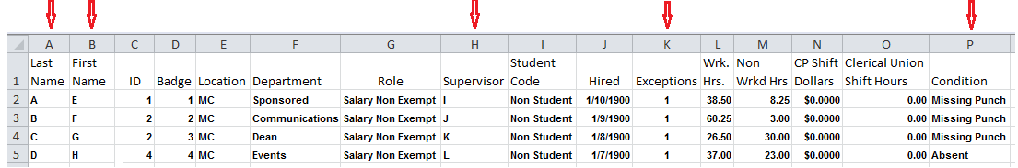

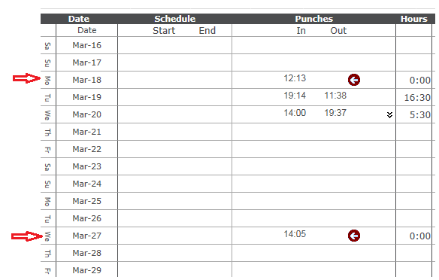

- Sort the report by the employee’s last name, first name, Supervisor and CP Shift Dollars. Send an email to the employee’s supervisor advising the error needs to be corrected to the first day after the employee started the University.

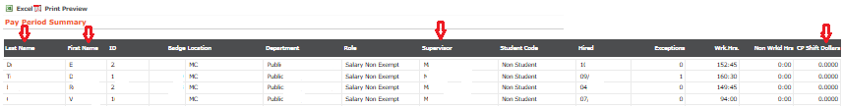

- Click the “Hours” to ensure the total hours are divisible by 7.5.
If no proceed to step 12, if yes proceed to step 15.
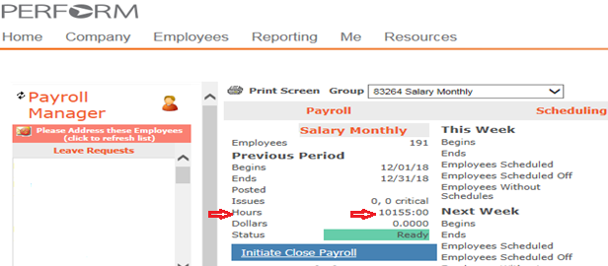

- Click Excel to transfer the information into an excel file to review.
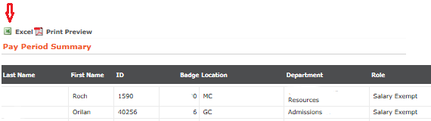

- Click “Open” to review your information.

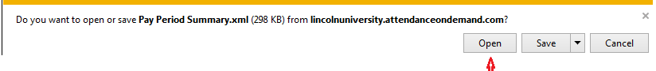

- Review the “Non Wrkd Hrs” to verify even numbers, if there are uneven numbers click on the number to review the employees PTO time request and correct if needed.

