Synopsis
This standard operating procedure (SOP) describes the steps needed in order to process a manual check request. The manual check request is approved by management.

Systems Needed:
Manual Check Form

Internal Departments Impacted:
Payroll
Accounting
Employees
Human Resources (HR)

- Use Check Request form located at the desk of the Payroll Specialist. 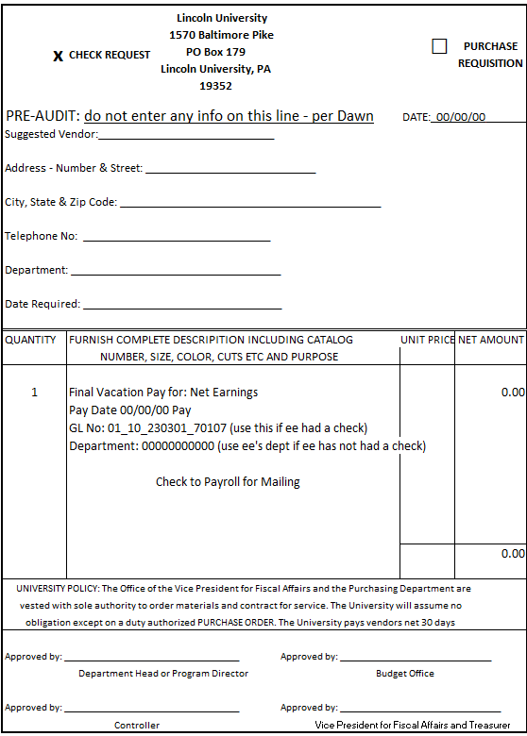
- Enter your information on the check request form.
  - Put an X Check Request (do not use Purchase Requisition)
  - Today’s date
  - Suggested Vendor: Employee ID Number and Name
  - Employee Address, City, State and Zip Code
  - Employee Telephone Number
  - Quantity: How many checks requesting (usually 1)
  - Description why you need check
  - Use either GL Number or Department Number (not both)
  - GL is if the employee has had a manual check before
  - Department Number is if no check has been requested until now
  - Add dollar amount of the check and total at the bottom
  - Attach for form supporting documentation to validate your request
  - Have manager and controller sign check request form
  - Give form to Financial Assistant
  - When you receive your live check mail or hand to the employee

