VSP Benefit Reconciliation
SYNOPSIS: VSP (Vision Services Plan) is the vision provider at Lincoln University. Every month, Lincoln is invoiced by the provider for the benefit cost for the subsequent month. The Payroll Benefit representative at Lincoln will then provide the information, including all charging instructions, to AP who will issue the payment to the provider. In addition the Payroll Benefit representative will reconcile the invoice detail to the Payroll employee and employer deductions to ensure the validity of invoice charges. Reconciling items may be due to the fact that the invoicing is done in advance, not in real time. Invoices include a Member Activity page of retroactive charges or credits. In addition there will always be outstanding payroll transactions not reflected on the invoice. Each year a schedule is built for the 9 month employees in order to assist in reconciling the prepayment of their health premiums. This procedure provides step by step instructions on how to complete this process.

STAKEHOLDERS:
Lincoln University Employees who participate in the plan
Payroll / Benefit Department
Lincoln University HR
VSP

EQUIPMENT NEEDED:
Microsoft Excel
MS Access for Oracle
Adobe Reader

PROCESS STEPS:
- Log on to the Benefits Managers site on visionbenefits.vsp.com
Go to Manage Your Plan, and select Billing 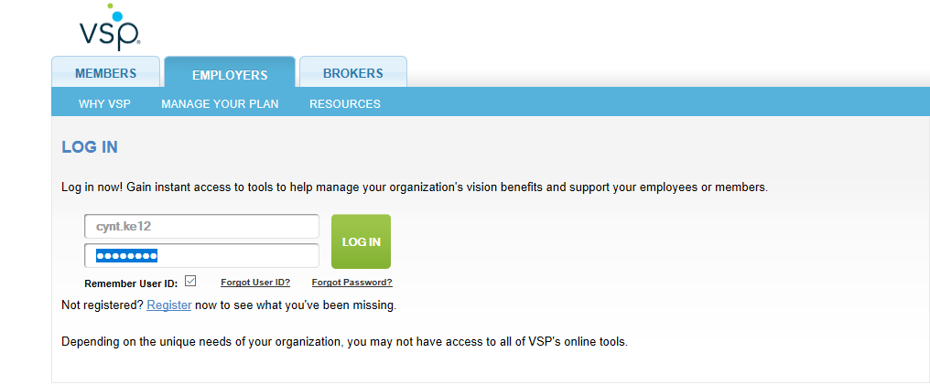 Once in employer portal, download each invoice. There are a total of 4 invoices to download (Base, Buy Up, Base Cobra and Buy Up Cobra)
- Save each invoice date specific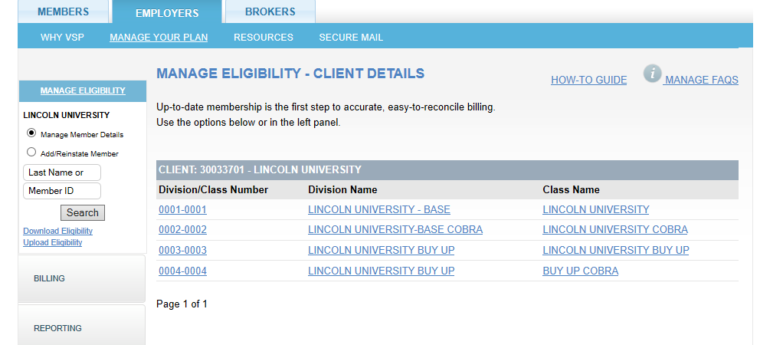

- Once the invoices have been downloaded click on “download eligibility” to the left of the page.
- Enter in the date of the information you are needing to retrieve and then click on dowmload.
- Save this in the VSP Reconcilaition Folder in the appropriate MM/YY Folder.
- Login into Paycor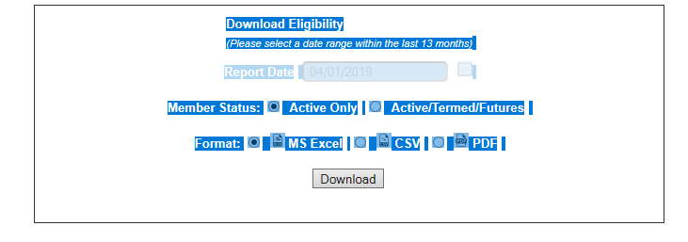
- Select Reporting
- Select Report and Analytics
- Select My Reports (you will have to select Custom Templates for the 1st execution of report)
- Select “Paid Benefits” and open report
- Select Filters and Change the ‘To’ date to the last pay of month of reconciliation
- Select Run Report
- Select Action (Open Report Results)
- Save As \\fs2\departments\HR_payroll\VSP reconciliation\paid benefits.xlsx
- Select Reporting / Create Reports and Analytics / My Reports
- Select “Benefit Reconciliation Data”
- Select Export
- Select Save As \\fs2\departments\HR_payroll\VSP reconciliation\benefit reconciliation data.xlsx

- Open VSP reconciliation. Accdb using 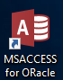
- Select Reconciliation setup - Enter the Coverage Period End date from the invoice
- Select Create work files and identify missing Member ID’s
- Select Update missing SSN and EMP ID for new Member ID’s. This will confirm both the payroll and invoice totals to ensure all records imported correctly.
- Enter the unmasked SSN’s and Employee Id’s to the table.
- Select Reconcile VSP invoice to Payroll for month – You may get a report showing duplicates. These are probably due to SSN changes. Make sure to remove any duplicate records from the file.
- Select “Export the reconciliation results” – Creates\\fs2\departments\HR_payroll\VSP reconciliation\Delta_reconciliation.xlsx
- Select Exit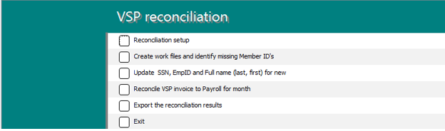
- Rename VSP_reconciliation.xlsx to Month specific
- Print the adjustment detail page from the VSP_invoice.xlsx and apply any adjustments to prior months reconciliations

